# Hierarchical Clustering

Hierarchical clustering involves creating clusters that have a predetermined ordering from top to bottom. For example, all files and folders on the hard disk are organized in a hierarchy. There are two types of hierarchical clustering, Divisive and Agglomerative.

**Divisive method**

In this method we assign all of the observations to a single cluster and then partition the cluster to two least similar clusters. Finally, we proceed recursively on each cluster until there is one cluster for each observation.

**Agglomerative method** In this method we assign each observation to its own cluster. Then, compute the similarity (e.g., distance) between each of the clusters and join the two most similar clusters. Finally, repeat steps 2 and 3 until there is only a single cluster left.

## Linkage or distance matrix

Before any clustering is performed, it is required to determine the proximity matrix containing the distance between each point using a distance function. Then, the matrix is updated to display the distance between each cluster. The following three methods differ in how the distance between each cluster is measured.

**Single Linkage** In single linkage hierarchical clustering, the distance between two clusters is defined as the shortest distance between two points in each cluster. For example, the distance between clusters “r” and “s” to the left is equal to the length of the arrow between their two closest points.

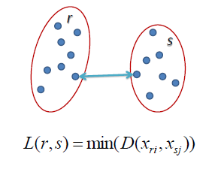

**Complete Linkage** In complete linkage hierarchical clustering, the distance between two clusters is defined as the longest distance between two points in each cluster. For example, the distance between clusters “r” and “s” to the left is equal to the length of the arrow between their two furthest points.

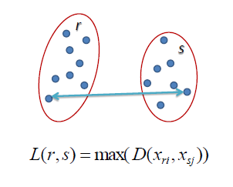

**Average Linkage** In average linkage hierarchical clustering, the distance between two clusters is defined as the average distance between each point in one cluster to every point in the other cluster. For example, the distance between clusters “r” and “s” to the left is equal to the average length each arrow between connecting the points of one cluster to the other.

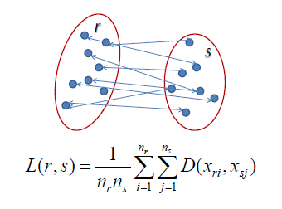

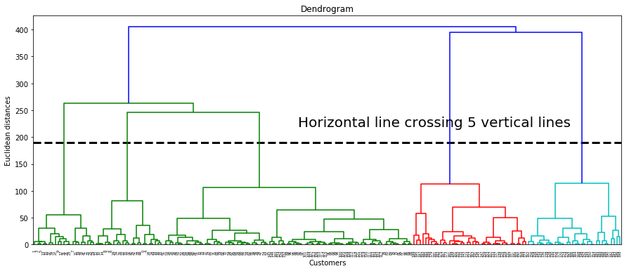

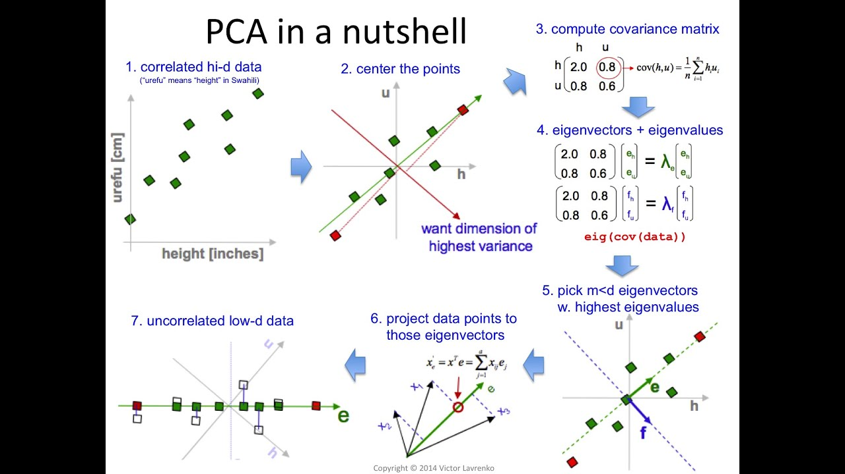

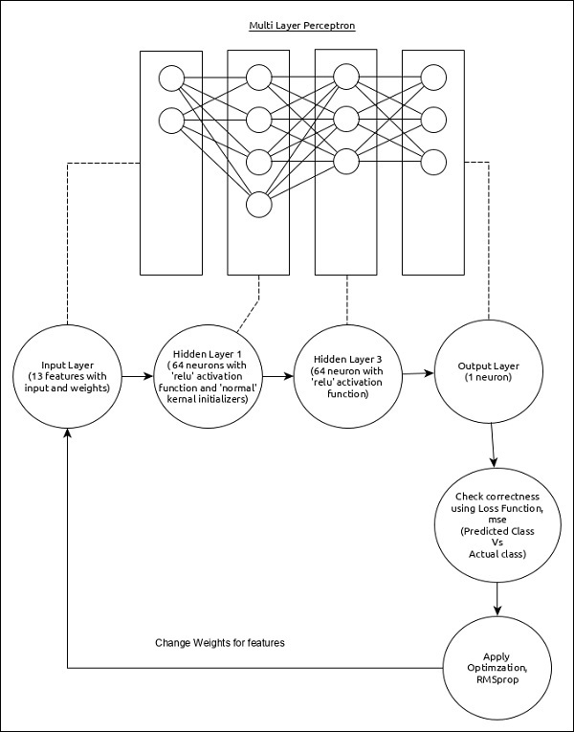

The core features of the model are as follows −

* Input layer consists of (13,) values.
* First layer, *Dense* consists of 64 units and ‘relu’ activation function with ‘normal’ kernel initializer.
* Second layer, *Dense* consists of 64 units and ‘relu’ activation function.
* Output layer, *Dense* consists of 1 unit.
* Use **mse** as loss function.
* Use **RMSprop** as Optimizer.
* Use **accuracy** as metrics.
* Use 128 as batch size.
* Use 500 as epochs.

**Step 1 − Import the modules**

Let us import the necessary modules.

import keras

from keras.datasets import boston_housing

from keras.models import Sequential

from keras.layers import Dense

from keras.optimizers import RMSprop

from keras.callbacks import EarlyStopping

from sklearn import preprocessing

from sklearn.preprocessing import scale

**Step 2 − Load data**

Let us import the Boston housing dataset.

(x_train, y_train), (x_test, y_test) = boston_housing.load_data()

Here,

**boston_housing** is a dataset provided by Keras. It represents a collection of housing information in Boston area, each having 13 features.

**Step 3 − Process the data**

Let us change the dataset according to our model, so that, we can feed into our model. The data can be changed using below code −

x_train_scaled = preprocessing.scale(x_train)

scaler = preprocessing.StandardScaler().fit(x_train)

x_test_scaled = scaler.transform(x_test)

Here, we have normalized the training data using **sklearn.preprocessing.scale** function. **preprocessing.StandardScaler().fit** function returns a scalar with the normalized mean and standard deviation of the training data, which we can apply to the test data using **scalar.transform** function. This will normalize the test data as well with the same setting as that of training data.

**Step 4 − Create the model**

Let us create the actual model.

model = Sequential()

model.add(Dense(64, kernel_initializer = 'normal', activation = 'relu',

input_shape = (13,)))

model.add(Dense(64, activation = 'relu')) model.add(Dense(1))

**Step 5 − Compile the model**

Let us compile the model using selected loss function, optimizer and metrics.

model.compile(

loss = 'mse',

optimizer = RMSprop(),

metrics = ['mean_absolute_error']

)

**Step 6 − Train the model**

Let us train the model using **fit()** method.

history = model.fit(

x_train_scaled, y_train,

batch_size=128,

epochs = 500,

verbose = 1,

validation_split = 0.2,

callbacks = [EarlyStopping(monitor = 'val_loss', patience = 20)]

)

Here, we have used callback function, **EarlyStopping**. The purpose of this callback is to monitor the loss value during each epoch and compare it with previous epoch loss value to find the improvement in the training. If there is no improvement for the **patience** times, then the whole process will be stopped.

Executing the application will give the below information as output −

Train on 323 samples, validate on 81 samples Epoch 1/500 2019-09-24 01:07:03.889046: I

tensorflow/core/platform/cpu_feature_guard.cc:142]

Your CPU supports instructions that this

TensorFlow binary was not co mpiled to use: AVX2 323/323

[==============================] - 0s 515us/step - loss: 562.3129

- mean_absolute_error: 21.8575 - val_loss: 621.6523 - val_mean_absolute_erro

r: 23.1730 Epoch 2/500

323/323 [==============================] - 0s 11us/step - loss: 545.1666

- mean_absolute_error: 21.4887 - val_loss: 605.1341 - val_mean_absolute_error

: 22.8293 Epoch 3/500

323/323 [==============================] - 0s 12us/step - loss: 528.9944

- mean_absolute_error: 21.1328 - val_loss: 588.6594 - val_mean_absolute_error

: 22.4799 Epoch 4/500

323/323 [==============================] - 0s 12us/step - loss: 512.2739

- mean_absolute_error: 20.7658 - val_loss: 570.3772 - val_mean_absolute_error

: 22.0853 Epoch 5/500

323/323 [==============================] - 0s 9us/step - loss: 493.9775

- mean_absolute_error: 20.3506 - val_loss: 550.9548 - val_mean_absolute_error: 21.6547

..........

..........

..........

Epoch 143/500

323/323 [==============================] - 0s 15us/step - loss: 8.1004

- mean_absolute_error: 2.0002 - val_loss: 14.6286 - val_mean_absolute_error:

2. 5904 Epoch 144/500

323/323 [==============================] - 0s 19us/step - loss: 8.0300

- mean_absolute_error: 1.9683 - val_loss: 14.5949 - val_mean_absolute_error:

2. 5843 Epoch 145/500

323/323 [==============================] - 0s 12us/step - loss: 7.8704

- mean_absolute_error: 1.9313 - val_loss: 14.3770 - val_mean_absolute_error: 2. 4996

**Step 7 − Evaluate the model**

Let us evaluate the model using test data.

score = model.evaluate(x_test_scaled, y_test, verbose = 0)

print('Test loss:', score[0])

print('Test accuracy:', score[1])

Executing the above code will output the below information −

Test loss: 21.928471583946077 Test accuracy: 2.9599233234629914

**Step 8 − Predict**

Finally, predict using test data as below −

prediction = model.predict(x_test_scaled)

print(prediction.flatten())

print(y_test)

The output of the above application is as follows −

[ 7.5612316 17.583357 21.09344 31.859276 25.055613 18.673872 26.600405 22.403967 19.060272 22.264952

17.4191 17.00466 15.58924 41.624374 20.220217 18.985565 26.419338 19.837091 19.946192 36.43445

12.278508 16.330965 20.701359 14.345301 21.741161 25.050423 31.046402 27.738455 9.959419 20.93039

20.069063 14.518344 33.20235 24.735163 18.7274 9.148898 15.781284 18.556862 18.692865 26.045074

27.954073 28.106823 15.272034 40.879818 29.33896 23.714525 26.427515 16.483374 22.518442 22.425386

33.94826 18.831465 13.2501955 15.537227 34.639984 27.468002 13.474407 48.134598 34.39617

22.8503124.042334 17.747198 14.7837715 18.187277 23.655672 22.364983 13.858193 22.710032 14.371148

7.1272087 35.960033 28.247292 25.3014 14.477208 25.306196 17.891165 20.193708 23.585173 34.690193

12.200583 20.102983 38.45882 14.741723 14.408362 17.67158 18.418497 21.151712 21.157492 22.693687

29.809034 19.366991 20.072294 25.880817 40.814568 34.64087 19.43741 36.2591 50.73806 26.968863 43.91787

32.54908 20.248306 ] [ 7.2 18.8 19. 27. 22.2 24.5 31.2 22.9 20.5 23.2 18.6 14.5 17.8 50. 20.8 24.3 24.2

19.8 19.1 22.7 12. 10.2 20. 18.5 20.9 23. 27.5 30.1 9.5 22. 21.2 14.1 33.1 23.4 20.1 7.4 15.4 23.8 20.1

24.5 33. 28.4 14.1 46.7 32.5 29.6 28.4 19.8 20.2 25. 35.4 20.3 9.7 14.5 34.9 26.6 7.2 50. 32.4 21.6 29.8

13.1 27.5 21.2 23.1 21.9 13. 23.2 8.1 5.6 21.7 29.6 19.6 7. 26.4 18.9 20.9 28.1 35.4 10.2 24.3 43.1 17.6

15.4 16.2 27.1 21.4 21.5 22.4 25. 16.6 18.6 22. 42.8 35.1 21.5 36. 21.9 24.1 50. 26.7 25. ]

linear_sample_score **=** []

poly_degree **=** []

**for** degree **in** range(degree_min,degree_max**+**1):

*#model = make_pipeline(PolynomialFeatures(degree), RidgeCV(alphas=ridge_alpha,normalize=True,cv=5))*

model **=** make_pipeline(PolynomialFeatures(degree), LassoCV(eps**=**lasso_eps,n_alphas**=**lasso_nalpha,

max_iter**=**lasso_iter,normalize**=True**,cv**=**5))

*#model = make_pipeline(PolynomialFeatures(degree), LinearRegression(normalize=True))*

model**.**fit(X_train, y_train)

y_pred **=** np**.**array(model**.**predict(X_train))

test_pred **=** np**.**array(model**.**predict(X_test))

RMSE**=**np**.**sqrt(np**.**sum(np**.**square(y_pred**-**y_train)))

test_score **=** model**.**score(X_test,y_test)

linear_sample_score**.**append(test_score)

poly_degree**.**append(degree)

print("Test score of model with degree {}: {}\n"**.**format(degree,test_score))

*#plt.figure()*

*#plt.title("RMSE: {}".format(RMSE),fontsize=10)*

*#plt.suptitle("Polynomial of degree {}".format(degree),fontsize=15)*

*#plt.xlabel("X training values")*

*#plt.ylabel("Fitted and training values")*

*#plt.scatter(X_train,y_pred)*

*#plt.scatter(X_train,y_train)*

plt**.**figure()

plt**.**title("Predicted vs. actual for polynomial of degree {}"**.**format(degree),fontsize**=**15)

plt**.**xlabel("Actual values")

plt**.**ylabel("Predicted values")

plt**.**scatter(y_test,test_pred)

plt**.**plot(y_test,y_test,'r',lw**=**2)

<https://github.com/tirthajyoti/Machine-Learning-with-Python/tree/master/Deployment/Linear_regression>

<https://github.com/tirthajyoti/Machine-Learning-with-Python/tree/master/Deployment/rnn_app>

There are two basic kinds of multicollinearity:

* **Structural multicollinearity**: This type occurs when we create a model term using other terms. In other words, it’s a byproduct of the model that we specify rather than being present in the data itself. For example, if you square term X to model curvature, clearly there is a correlation between X and X2.
* **Data multicollinearity**: This type of multicollinearity is present in the data itself rather than being an artifact of our model. Observational experiments are more likely to exhibit this kind of multicollinearity.

## Testing for Multicollinearity with Variance Inflation Factors (VIF)

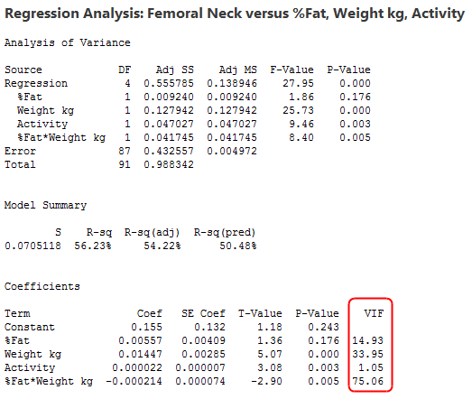

## Center the Independent Variables to Reduce Structural Multicollinearity

In our model, the interaction term is at least partially responsible for the high VIFs. Both higher-order terms and interaction terms produce multicollinearity because these terms include the main effects. Centering the variables is a simple way to reduce structural multicollinearity.

Centering the variables is also known as standardizing the variables by subtracting the mean. This process involves calculating the mean for each continuous independent variable and then subtracting the mean from all observed values of that variable. Then, use these centered variables in your model. Most statistical software provides the feature of fitting your model using [standardized](https://statisticsbyjim.com/glossary/standardization/) variables.

he potential solutions include the following:

* Remove some of the highly correlated independent variables.
* Linearly combine the independent variables, such as adding them together.
* Perform an analysis designed for highly correlated variables, such as principal components analysis or partial least squares regression.
* LASSO and Ridge regression are advanced forms of regression analysis that can handle multicollinearity. If you know how to perform [linear least squares](https://statisticsbyjim.com/glossary/ordinary-least-squares/) regression, you’ll be able to handle these analyses with just a little additional study.

**Gradient Boosting:** GBT build trees one at a time, where each new tree helps to correct errors made by previously trained tree.

B) Strengths of the model  
Since boosted trees are derived by optimizing an objective function, basically GBM can be used to solve almost all objective function that we can write gradient out. This including things like ranking and poission regression, which RF is harder to achieve.

C) Weaknesses of the model

* GBMs are more sensitive to overfitting if the data is noisy.
* Training generally takes longer because of the fact that trees are built sequentially.
* GBMs are harder to tune than RF. There are typically three parameters: number of trees, depth of trees and learning rate, and each tree built is generally shallow.

Some examples of algorithms where feature scaling matters are:

* k-nearest neighbors with an Euclidean distance measure if want all features to contribute equally
* k-means (see k-nearest neighbors)
* logistic regression, SVMs, perceptrons, neural networks etc. if you are using gradient descent/ascent-based optimization, otherwise some weights will update much faster than others
* linear discriminant analysis, principal component analysis, kernel principal component analysis since you want to find directions of maximizing the variance (under the constraints that those directions/eigenvectors/principal components are orthogonal); you want to have features on the same scale since you’d emphasize variables on “larger measurement scales” more. There are many more cases than I can possibly list here … I always recommend you to think about the algorithm and what it’s doing, and then it typically becomes obvious whether we want to scale your features or not.

## Z-score standardization or Min-Max scaling? [#](https://sebastianraschka.com/Articles/2014_about_feature_scaling.html#z-score-standardization-or-min-max-scaling)

“Standardization or Min-Max scaling?” - There is no obvious answer to this question: it really depends on the application.

For example, in clustering analyses, standardization may be especially crucial in order to compare similarities between features based on certain distance measures. Another prominent example is the Principal Component Analysis, where we usually prefer standardization over Min-Max scaling, since we are interested in the components that maximize the variance (depending on the question and if the PCA computes the components via the correlation matrix instead of the covariance matrix; [but more about PCA in my previous article](http://sebastianraschka.com/Articles/2014_pca_step_by_step.html)).

However, this doesn’t mean that Min-Max scaling is not useful at all! A popular application is image processing, where pixel intensities have to be normalized to fit within a certain range (i.e., 0 to 255 for the RGB color range). Also, typical neural network algorithm require data that on a 0-1 scale.

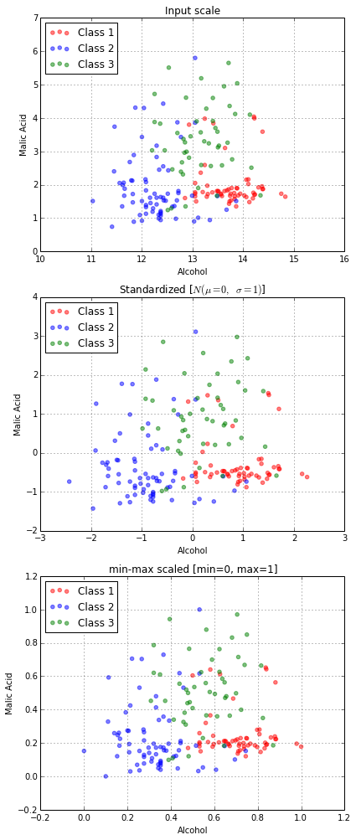

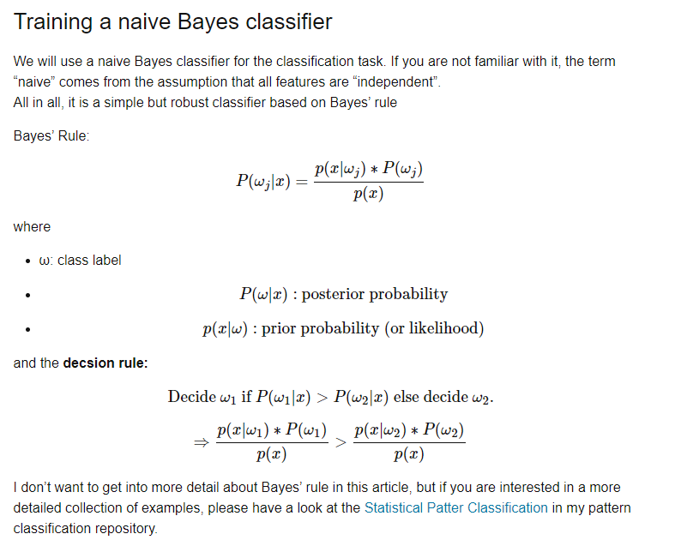

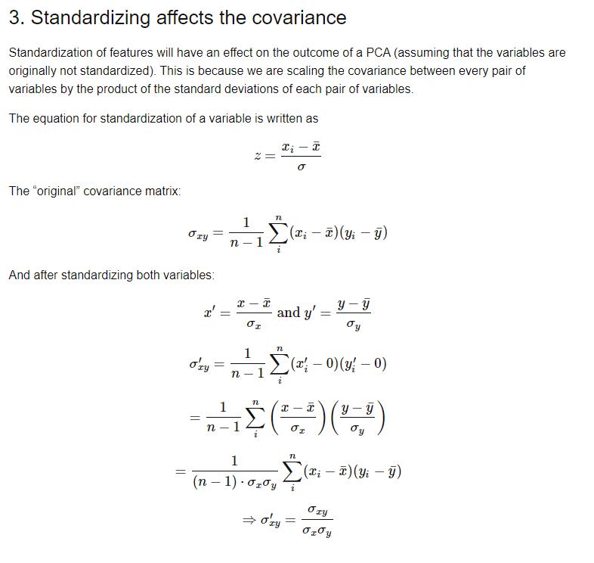

## Generative classifiers

* ‌Naïve Bayes
* Bayesian networks
* Markov random fields
* ‌Hidden Markov Models (HMM)

## Discriminative Classifiers

* ‌Logistic regression
* Scalar Vector Machine
* ‌Traditional neural networks
* ‌Nearest neighbour
* Conditional Random Fields (CRF)s

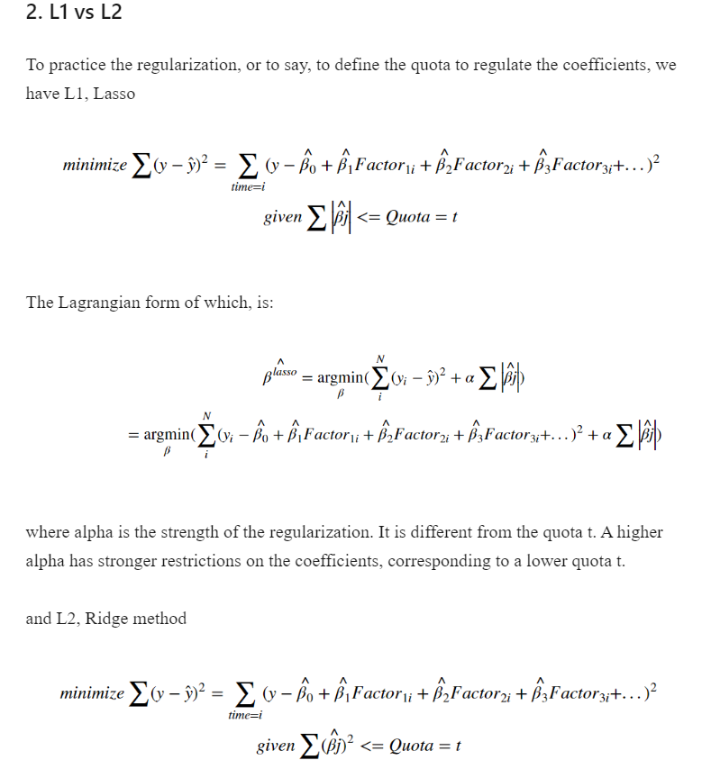

***The difference is that****: while shrinking the quota,****L1 tends to cut off some factors by turning their coefficients to zero****, while L2 tend****s to shrinking these coefficients to a tiny number (none zero)****, keep some of their influence on Y.*

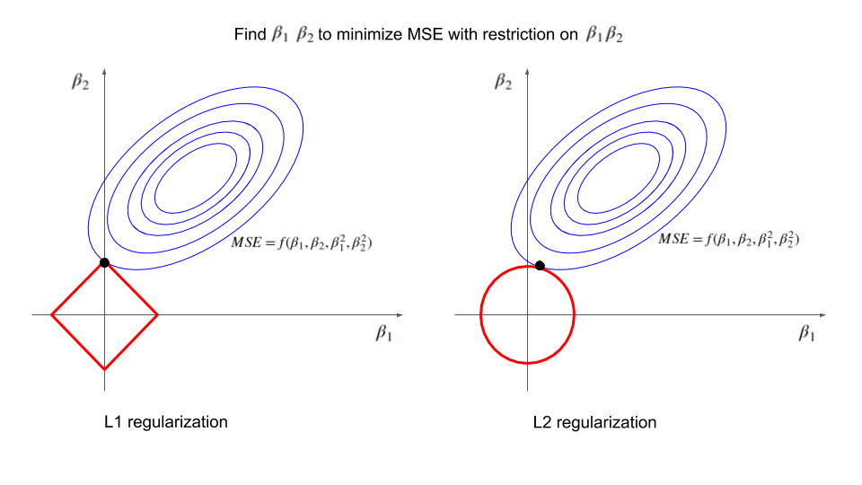

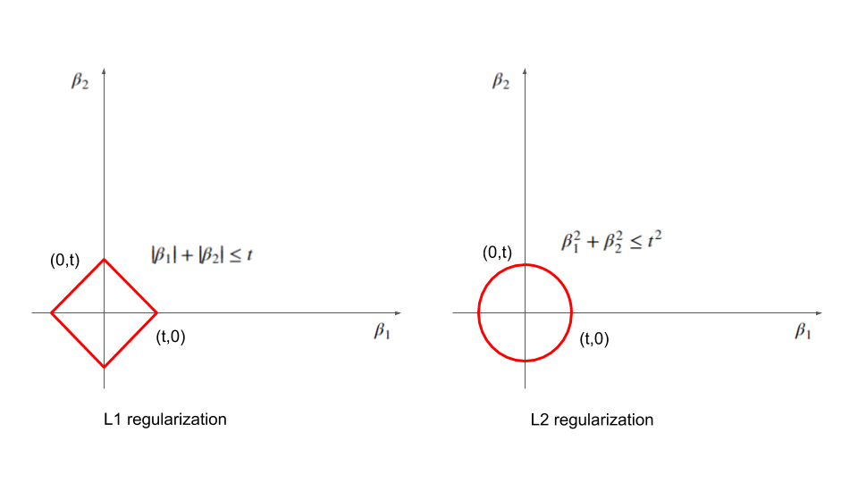

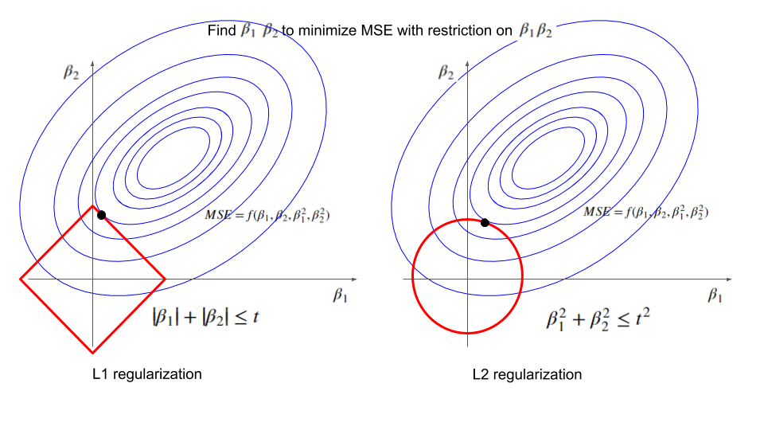

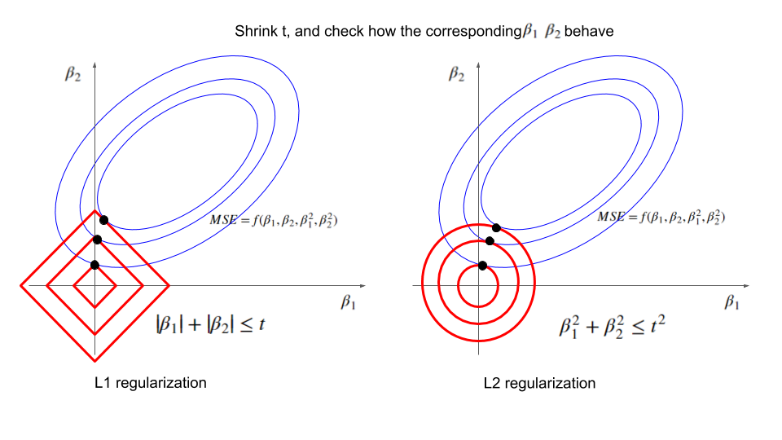

**With the decease of t, both methods get smaller beta1 and beta2. Here comes the difference between L1 and L2: the tangent point for L1 cases is more likely to be achieved on the axis (some parameter be reduced to zero), while the tangent point for L2 cases is more likely to be got on a none-axis point (none zero points).**

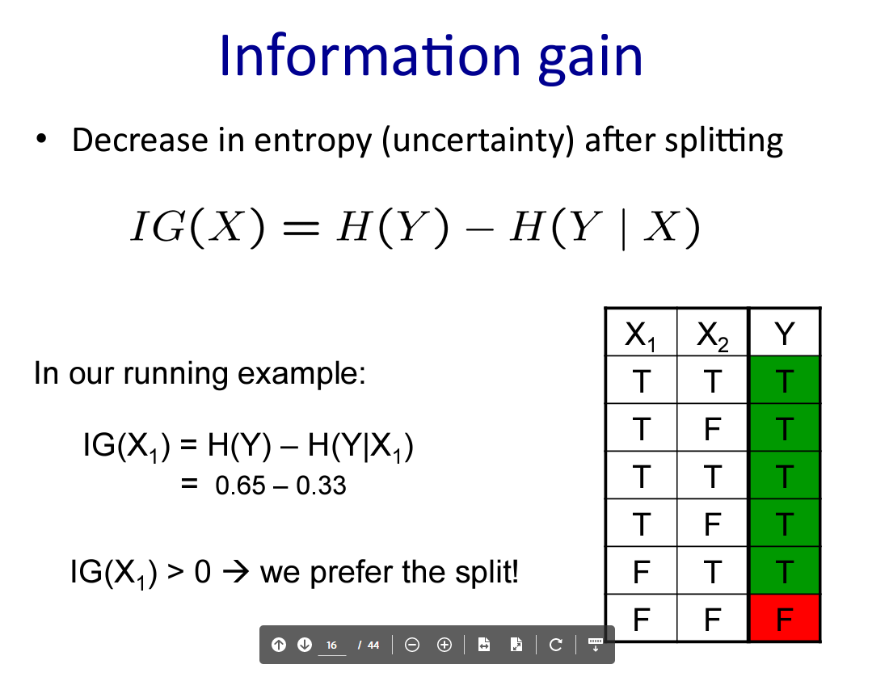

Bagging

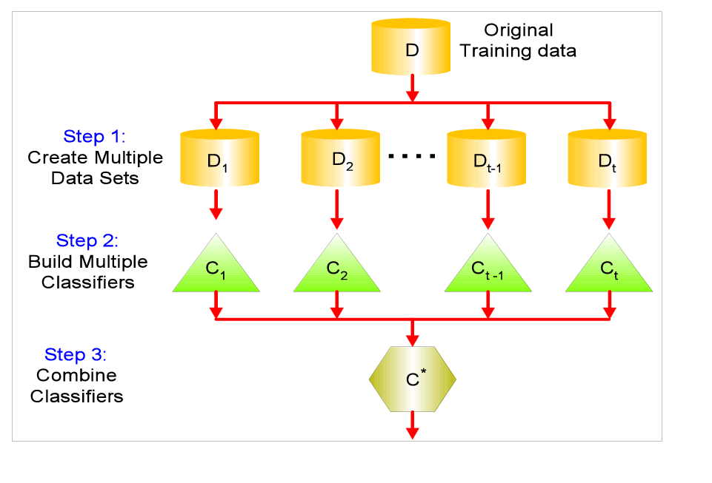

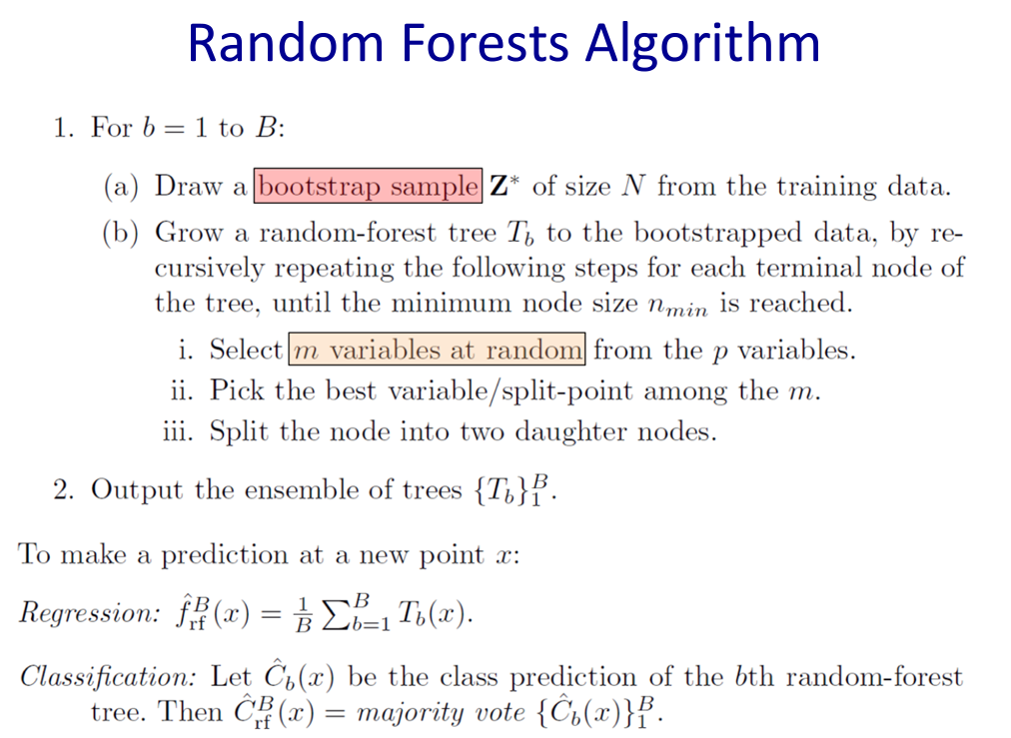

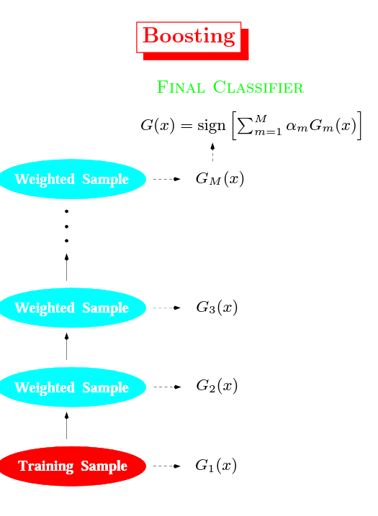

# Everything you did and didn't know about PCA

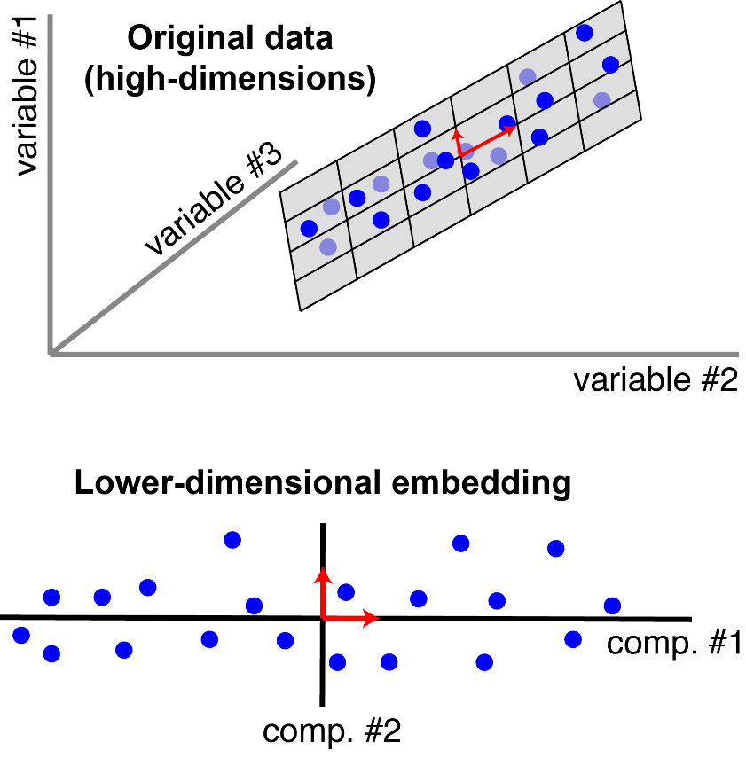

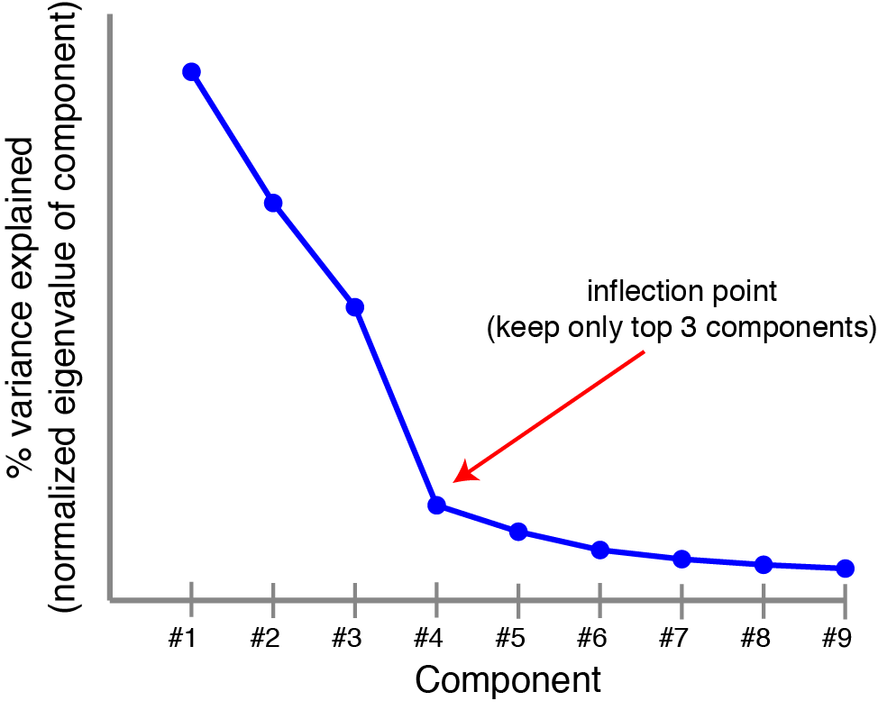

### Expectation Maximization

K-Means is really just the EM (Expectation Maximization) algorithm applied to a particular naive bayes model.

To demonstrate this remarkable claim, consider the classic naive bayes model with a class variable which can take on discrete values (with domain size $k$) and a set of feature variables, each of which can take on a continuous value (see figure 2). The conditional probability distributions for $P(f_i = x | C= c)$ is going to be slightly different than usual. Instead of storing this conditional probability as a table, we are going to store it as a single [normal](https://en.wikipedia.org/wiki/Normal_distribution) (gaussian) distribution, with it's own mean and a standard deviation of 1. Specifically, this means that: $P(f_i = x | C= c) \sim \mathcal{N}(\mu_{c,i}, 1)$

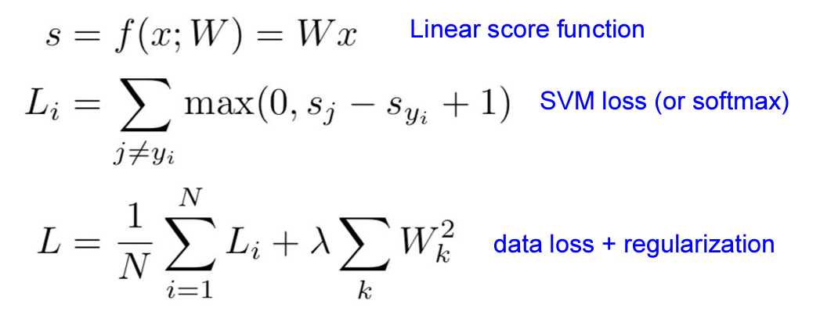

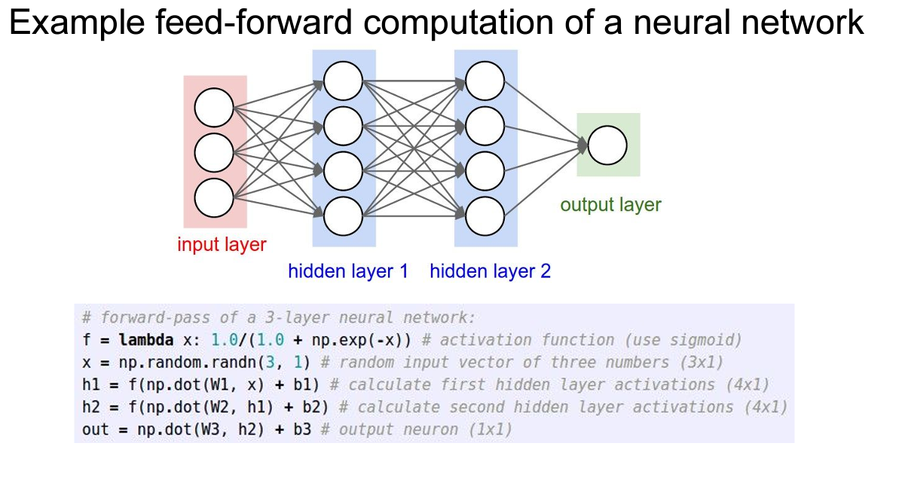

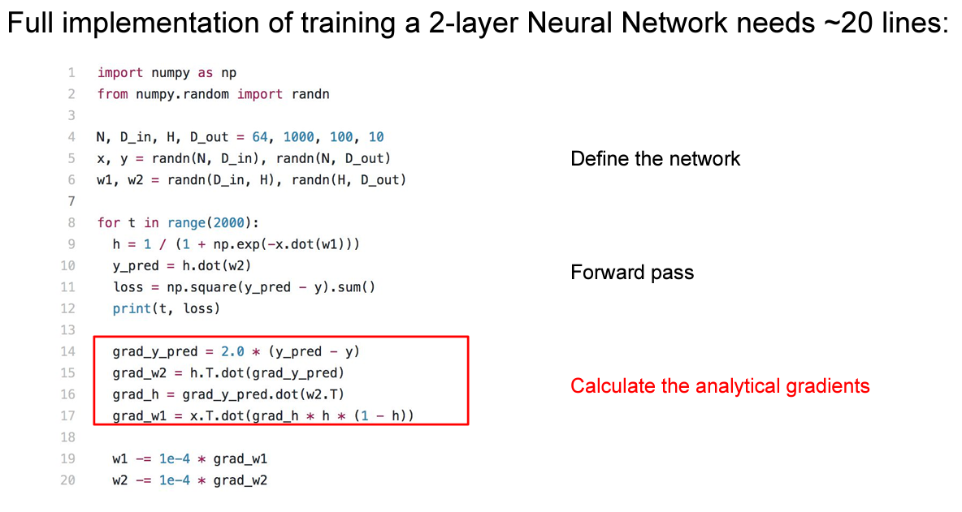

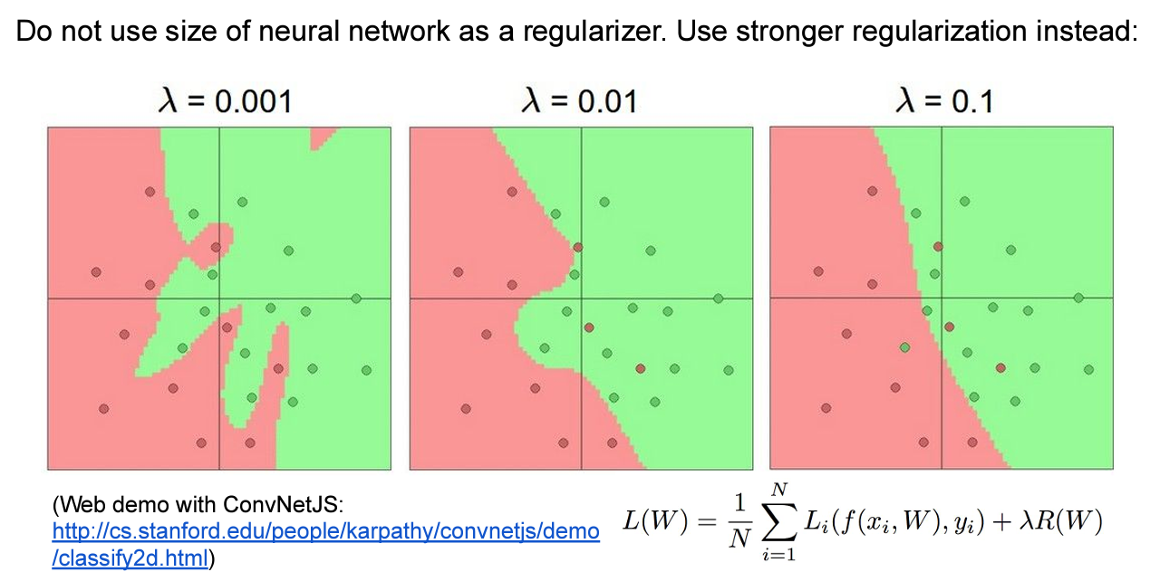

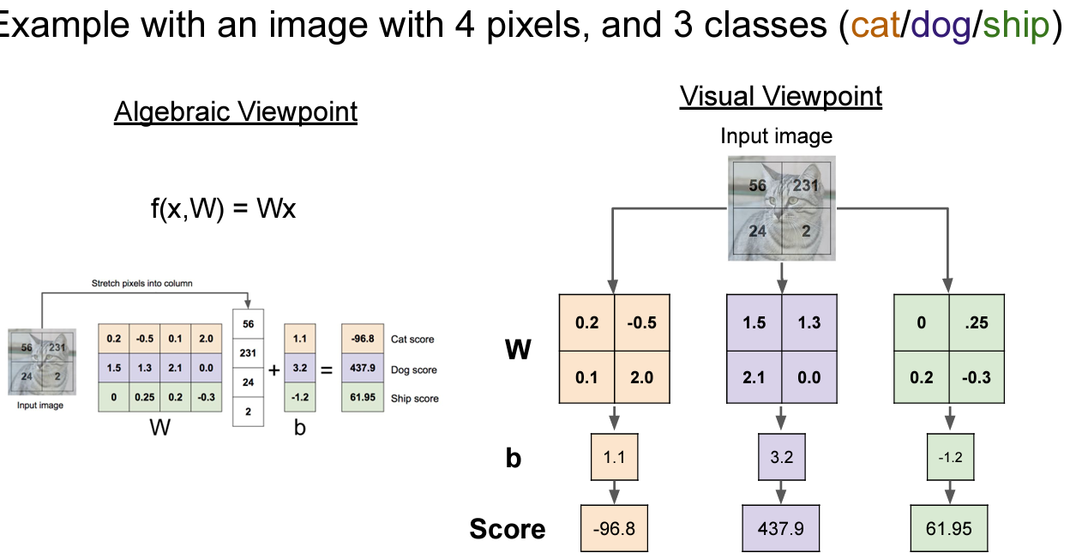

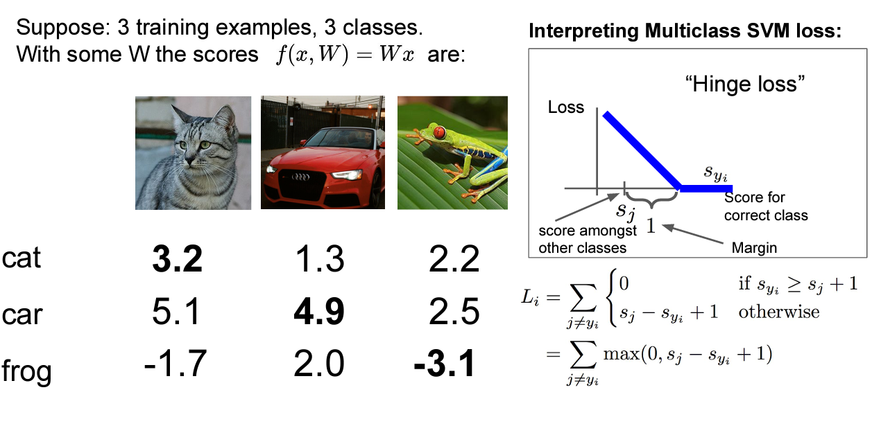

*A ConvNet is made up of Layers. Every Layer has a simple API: It transforms an input 3D volume to an output 3D volume with some differentiable function that may or may not have parameters.*

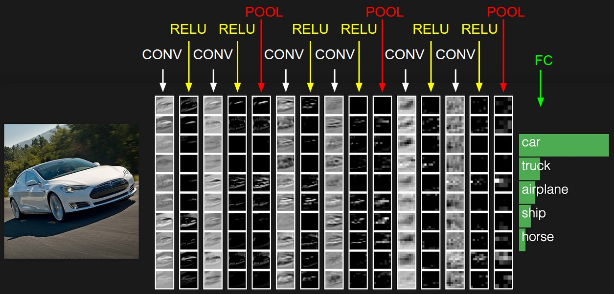

**Spatial arrangement**. We have explained the connectivity of each neuron in the Conv Layer to the input volume, but we haven’t yet discussed how many neurons there are in the output volume or how they are arranged. Three hyperparameters control the size of the output volume: the **depth, stride** and **zero-padding**. We discuss these next:

1. First, the **depth** of the output volume is a hyperparameter: it corresponds to the number of filters we would like to use, each learning to look for something different in the input. For example, if the first Convolutional Layer takes as input the raw image, then different neurons along the depth dimension may activate in presence of various oriented edges, or blobs of color. We will refer to a set of neurons that are all looking at the same region of the input as a **depth column** (some people also prefer the term fibre).
2. Second, we must specify the **stride** with which we slide the filter. When the stride is 1 then we move the filters one pixel at a time. When the stride is 2 (or uncommonly 3 or more, though this is rare in practice) then the filters jump 2 pixels at a time as we slide them around. This will produce smaller output volumes spatially.
3. As we will soon see, sometimes it will be convenient to pad the input volume with zeros around the border. The size of this **zero-padding** is a hyperparameter. The nice feature of zero padding is that it will allow us to control the spatial size of the output volumes (most commonly as we’ll see soon we will use it to exactly preserve the spatial size of the input volume so the input and output width and height are the same).

**Parameter Sharing.** Parameter sharing scheme is used in Convolutional Layers to control the number of parameters. Using the real-world example above, we see that there are 55*55*96 = 290,400 neurons in the first Conv Layer, and each has 11*11*3 = 363 weights and 1 bias. Together, this adds up to 290400 * 364 = 105,705,600 parameters on the first layer of the ConvNet alone. Clearly, this number is very high.

It turns out that we can dramatically reduce the number of parameters by making one reasonable assumption: That if one feature is useful to compute at some spatial position (x,y), then it should also be useful to compute at a different position (x2,y2).

**Summary**. To summarize, the Conv Layer:

* Accepts a volume of size W1×H1×D1W1×H1×D1
* Requires four hyperparameters:
  + Number of filters KK,
  + their spatial extent FF,
  + the stride SS,
  + the amount of zero padding PP.
* Produces a volume of size W2×H2×D2W2×H2×D2 where:
  + W2=(W1−F+2P)/S+1W2=(W1−F+2P)/S+1
  + H2=(H1−F+2P)/S+1H2=(H1−F+2P)/S+1 (i.e. width and height are computed equally by symmetry)
  + D2=KD2=K
* With parameter sharing, it introduces F⋅F⋅D1F⋅F⋅D1 weights per filter, for a total of (F⋅F⋅D1)⋅K(F⋅F⋅D1)⋅K weights and KK biases.
* In the output volume, the dd-th depth slice (of size W2×H2W2×H2) is the result of performing a valid convolution of the dd-th filter over the input volume with a stride of SS, and then offset by dd-th bias.

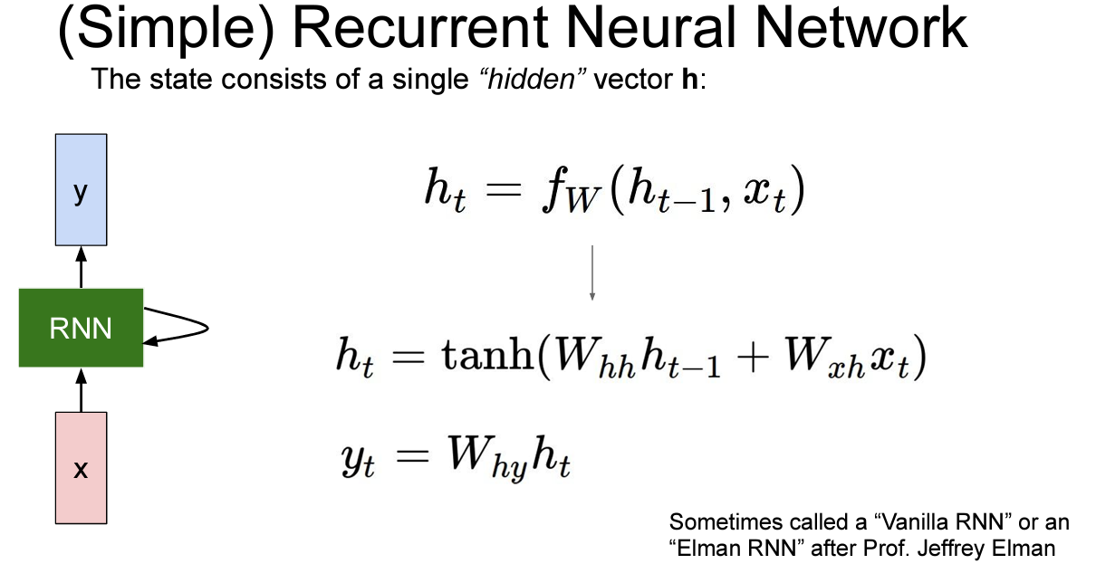

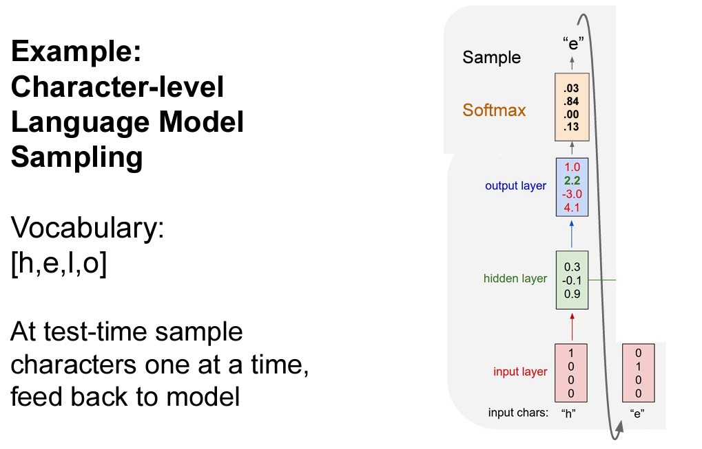

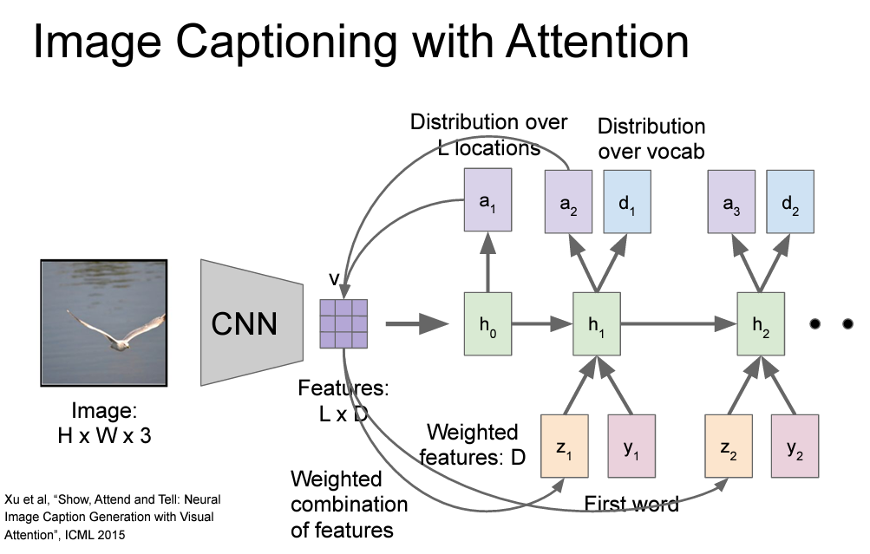

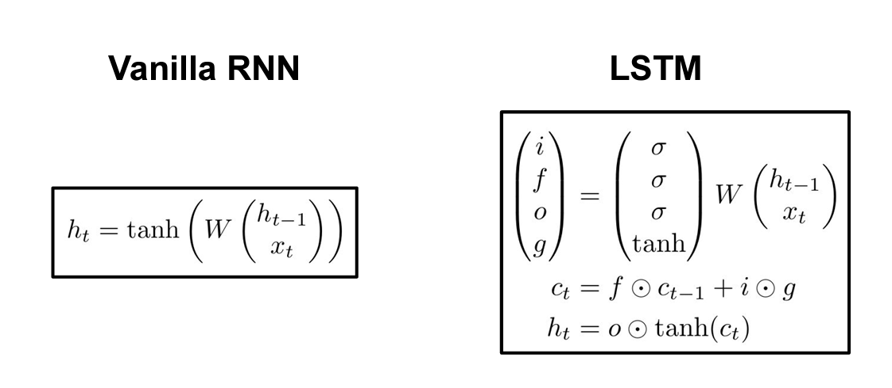

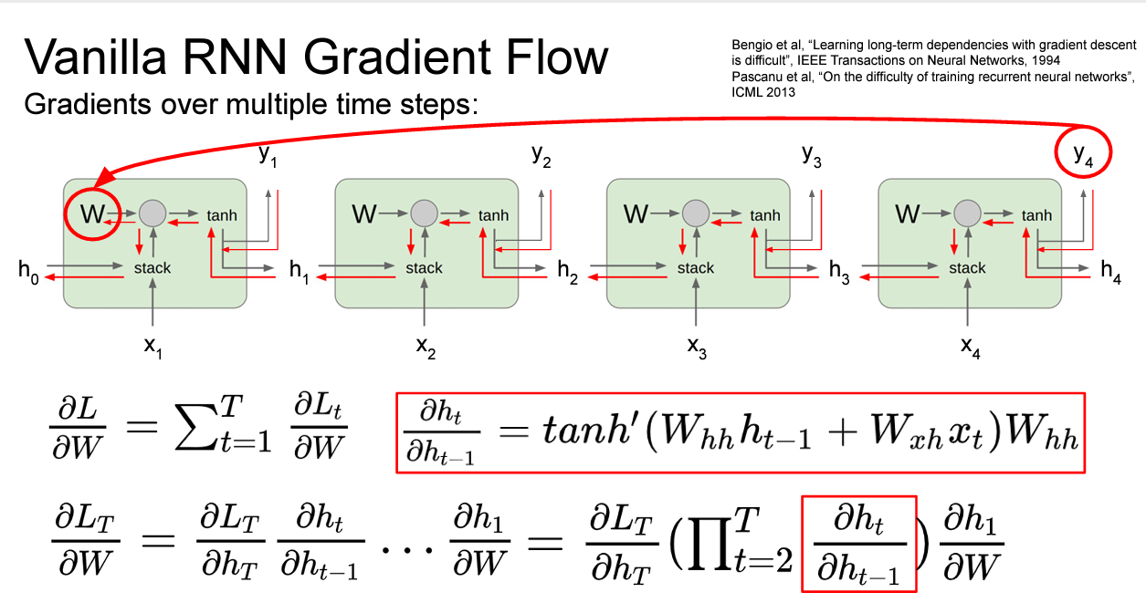

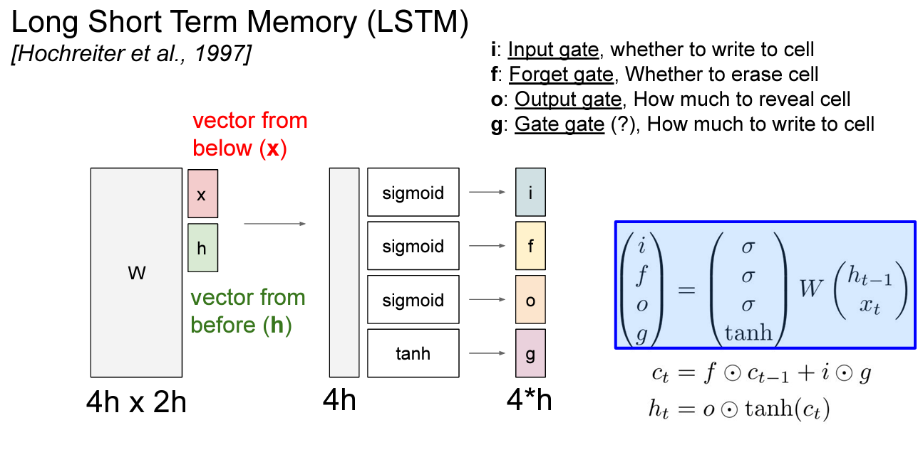

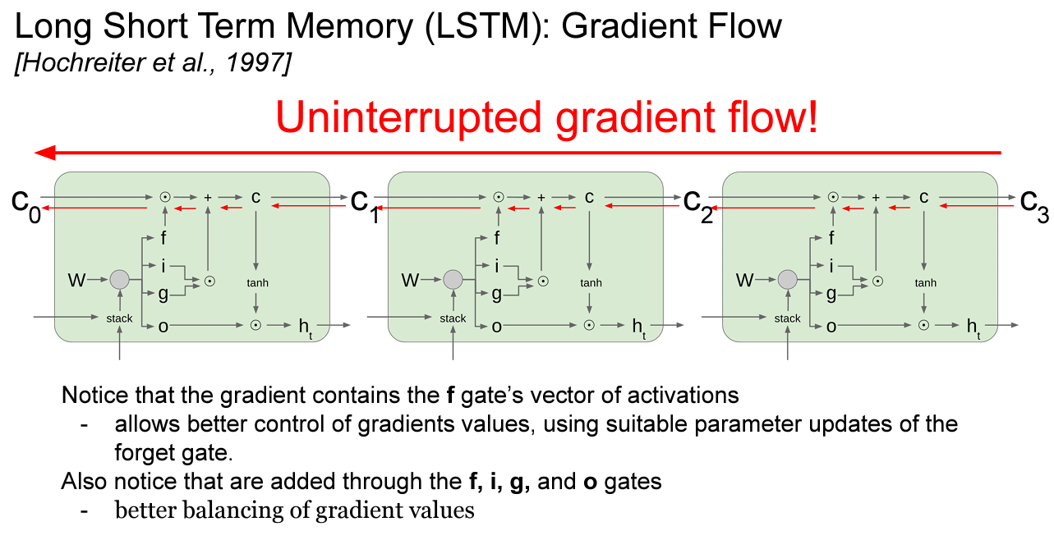

SPARK

<https://datastrophic.io/core-concepts-architecture-and-internals-of-apache-spark/>

sqlContext.sql {

"""

SELECT count()

FROM cassandra_event_rollups

JOIN mongo_event_rollups

ON cassandra_event_rollups.uuid = cassandra_event_rollups.uuid

WHERE cassandra_event_rollups.value != cassandra_event_rollups.value

""".stripMargin

}



### RDD: Resilient Distributed Datasets

RDD could be thought of as an immutable parallel data structure with failure recovery possibilities. It provides API for various transformations and materializations of data as well as for control over caching and partitioning of elements to optimize data placement. RDD can be created either from external storage or from another RDD and stores information about its parents to optimize execution (via pipelining of operations) and recompute partition in case of failure.

From a developer’s point of view, RDD represents distributed immutable data (partitioned data + iterator) and lazily evaluated operations (transformations).

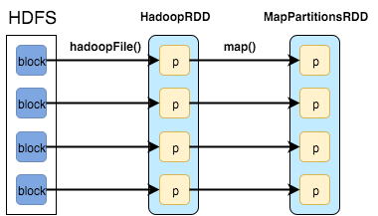

**RDD Operations** Operations on RDDs are divided into several groups:

* Transformations
  + apply user function to every element in a partition (or to the whole partition)
  + apply aggregation function to the whole dataset (groupBy, sortBy)
  + introduce dependencies between RDDs to form DAG
  + provide functionality for repartitioning (repartition, partitionBy)
* Actions
  + trigger job execution
  + used to materialize computation results
* Extra: persistence
  + explicitly store RDDs in memory, on disk or off-heap (cache, persist)
  + checkpointing for truncating RDD lineage



**Production level deep learning**

[**https://github.com/prakhargurawa/Production-Level-Deep-Learning**](https://github.com/prakhargurawa/Production-Level-Deep-Learning)

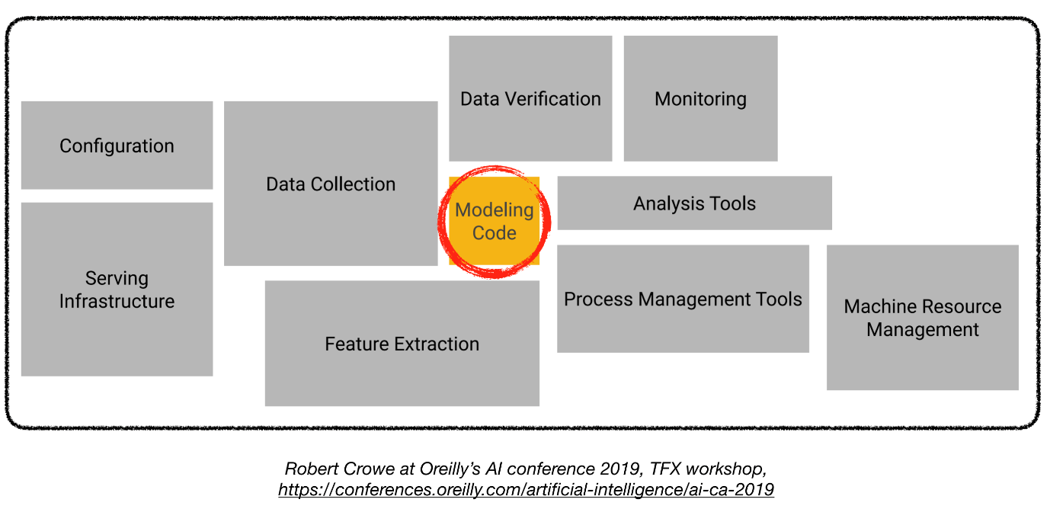

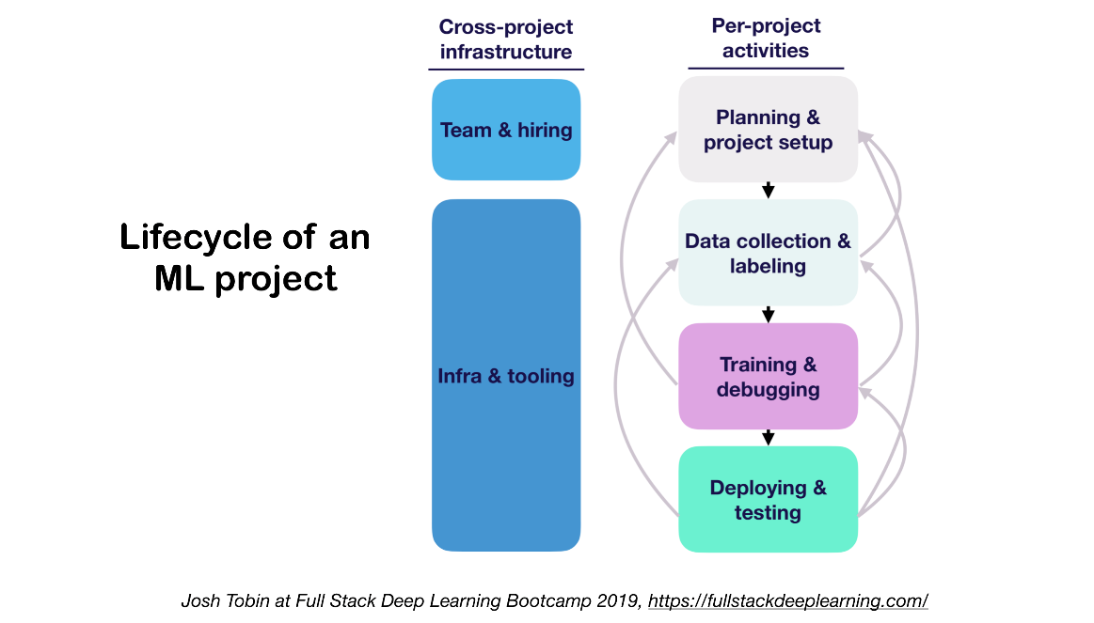

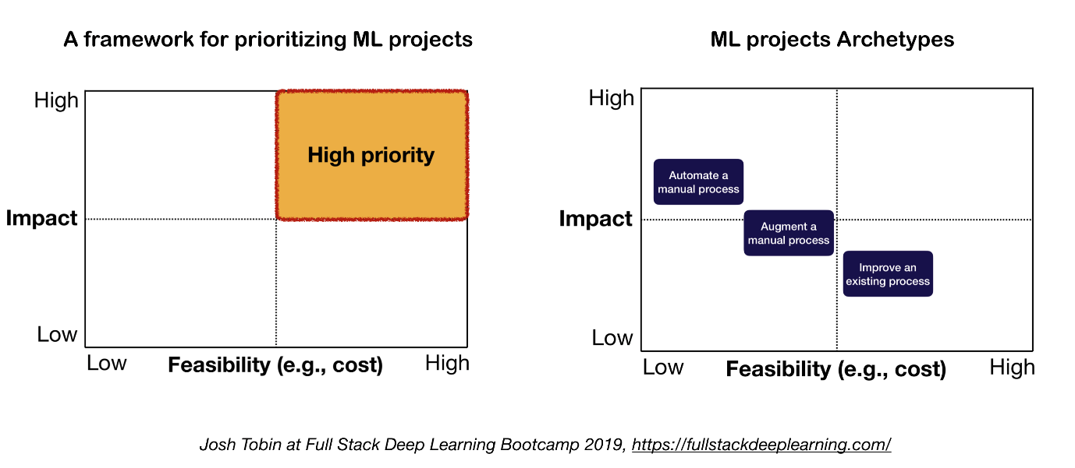

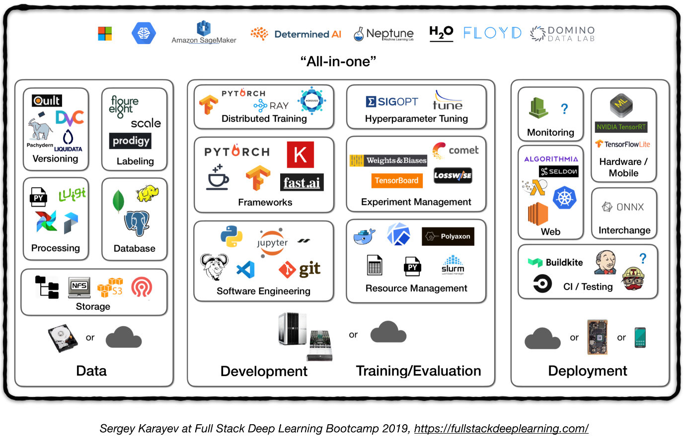

**1. Data Management**

**1.1 Data Sources**

* Supervised deep learning requires a lot of labeled data
* Labeling own data is costly!
* Here are some resources for data:
  + Open source data (good to start with, but not an advantage)
  + Data augmentation (a MUST for computer vision, an option for NLP)
  + Synthetic data (almost always worth starting with, esp. in NLP)

**1.2 Data Labeling**

* Requires: separate software stack (labeling platforms), temporary labor, and QC
* Sources of labor for labeling:
  + Crowdsourcing (Mechanical Turk): cheap and scalable, less reliable, needs QC
  + Hiring own annotators: less QC needed, expensive, slow to scale
  + Data labeling service companies

**1.3. Data Storage**

* Data storage options:
  + **Object store**: Store binary data (images, sound files, compressed texts)
    - [Amazon S3](https://aws.amazon.com/s3/)
    - [Ceph](https://ceph.io/) Object Store
  + **Database**: Store metadata (file paths, labels, user activity, etc).
    - [Postgres](https://www.postgresql.org/) is the right choice for most of applications, with the best-in-class SQL and great support for unstructured JSON.
  + **Data Lake**: to aggregate features which are not obtainable from database (e.g. logs)
    - [Amazon Redshift](https://aws.amazon.com/redshift/)
  + **Feature Store**: store, access, and share machine learning features (Feature extraction could be computationally expensive and nearly impossible to scale, hence re-using features by different models and teams is a key to high performance ML teams).
    - [FEAST](https://github.com/gojek/feast) (Google cloud, Open Source)
    - [Michelangelo Palette](https://eng.uber.com/michelangelo/) (Uber)
* Suggestion: At training time, copy data into a local or networked **filesystem** (NFS).

**1.4. Data Versioning**

* It's a "MUST" for deployed ML models:  
  **Deployed ML models are part code, part data**. [1](https://github.com/prakhargurawa/Production-Level-Deep-Learning#fsdl) No data versioning means no model versioning.
* Data versioning platforms:
  + [DVC](https://dvc.org/): Open source version control system for ML projects
  + [Pachyderm](https://www.pachyderm.com/): version control for data
  + [Dolt](https://github.com/dolthub/dolt): a SQL database with Git-like version control for data and schema

**1.5. Data Processing**

* Training data for production models may come from different sources, including *Stored data in db and object stores*, *log processing*, and *outputs of other classifiers*.
* There are dependencies between tasks, each needs to be kicked off after its dependencies are finished. For example, training on new log data, requires a preprocessing step before training.
* Makefiles are not scalable. "Workflow manager"s become pretty essential in this regard.
* **Workflow orchestration:**
  + [Luigi](https://github.com/spotify/luigi) by Spotify
  + [Airflow](https://airflow.apache.org/) by Airbnb: Dynamic, extensible, elegant, and scalable (the most widely used)
    - DAG workflow
    - Robust conditional execution: retry in case of failure
    - Pusher supports docker images with tensorflow serving
    - Whole workflow in a single .py file

**2. Development, Training, and Evaluation**

**2.1. Software engineering**

* Winner language: Python
* Editors:
  + Vim
  + Emacs
  + [VS Code](https://code.visualstudio.com/) (Recommended by the author): Built-in git staging and diff, Lint code, open projects remotely through ssh
  + Notebooks: Great as starting point of the projects, hard to scale (fun fact: Netflix’s Notebook-Driven Architecture is an exception, which is entirely based on [nteract](https://nteract.io/) suites).
    - [nteract](https://nteract.io/): a next-gen React-based UI for Jupyter notebooks
    - [Papermill](https://github.com/nteract/papermill): is an [nteract](https://nteract.io/) library built for *parameterizing*, *executing*, and *analyzing* Jupyter Notebooks.
    - [Commuter](https://github.com/nteract/commuter): another [nteract](https://nteract.io/) project which provides a read-only display of notebooks (e.g. from S3 buckets).
  + [Streamlit](https://streamlit.io/): interactive data science tool with applets
* Compute recommendations [1](https://github.com/prakhargurawa/Production-Level-Deep-Learning#fsdl):
  + For *individuals* or *startups*:
    - Development: a 4x Turing-architecture PC
    - Training/Evaluation: Use the same 4x GPU PC. When running many experiments, either buy shared servers or use cloud instances.
  + For *large companies:*
    - Development: Buy a 4x Turing-architecture PC per ML scientist or let them use V100 instances
    - Training/Evaluation: Use cloud instances with proper provisioning and handling of failures
* Cloud Providers:
  + GCP: option to connect GPUs to any instance + has TPUs
  + AWS:

**2.2. Resource Management**

* Allocating free resources to programs
* Resource management options:
  + Old school cluster job scheduler ( e.g. [Slurm](https://slurm.schedmd.com/) workload manager )
  + Docker + Kubernetes
  + Kubeflow
  + [Polyaxon](https://polyaxon.com/) (paid features)

**2.3. DL Frameworks**

* Unless having a good reason not to, use Tensorflow/Keras or PyTorch. [1](https://github.com/prakhargurawa/Production-Level-Deep-Learning#fsdl)
* The following figure shows a comparison between different frameworks on how they stand for *"developement"* and *"production"*.

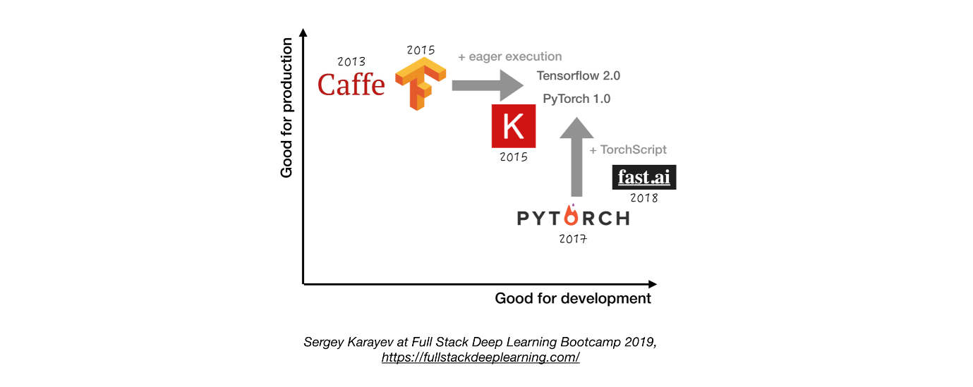

**2.4. Experiment management**

* Development, training, and evaluation strategy:
  + Always start **simple**
    - Train a small model on a small batch. Only if it works, scale to larger data and models, and hyperparameter tuning!
  + Experiment management tools:
  + [Tensorboard](https://www.tensorflow.org/tensorboard)
    - provides the visualization and tooling needed for ML experimentation
  + [Losswise](https://losswise.com/) (Monitoring for ML)
  + [Comet](https://www.comet.ml/): lets you track code, experiments, and results on ML projects
  + [Weights & Biases](https://www.wandb.com/): Record and visualize every detail of your research with easy collaboration
  + [MLFlow Tracking](https://www.mlflow.org/docs/latest/tracking.html#tracking): for logging parameters, code versions, metrics, and output files as well as visualization of the results.
    - Automatic experiment tracking with one line of code in python
    - Side by side comparison of experiments
    - Hyper parameter tuning
    - Supports Kubernetes based jobs

**2.5. Hyperparameter Tuning**

* Approaches:
  + Grid search
  + Random search
  + Bayesian Optimization
  + HyperBand and Asynchronous Successive Halving Algorithm (ASHA)
  + Population-based Training
* Platforms:
  + [RayTune](http://tune.io/): Ray Tune is a Python library for hyperparameter tuning at any scale (with a focus on deep learning and deep reinforcement learning). Supports any machine learning framework, including PyTorch, XGBoost, MXNet, and Keras.
  + [Katib](https://github.com/kubeflow/katib): Kubernete's Native System for Hyperparameter Tuning and Neural Architecture Search, inspired by [Google vizier](<https://static.googleusercontent.com/media/> research.google.com/ja//pubs/archive/ bcb15507f4b52991a0783013df4222240e942381.pdf) and supports multiple ML/DL frameworks (e.g. TensorFlow, MXNet, and PyTorch).
  + [Hyperas](https://maxpumperla.com/hyperas/): a simple wrapper around hyperopt for Keras, with a simple template notation to define hyper-parameter ranges to tune.
  + [SIGOPT](https://sigopt.com/): a scalable, enterprise-grade optimization platform
  + [Sweeps](https://docs.wandb.com/library/sweeps) from [Weights & Biases] (<https://www.wandb.com/>): Parameters are not explicitly specified by a developer. Instead they are approximated and learned by a machine learning model.
  + [Keras Tuner](https://github.com/keras-team/keras-tuner): A hyperparameter tuner for Keras, specifically for tf.keras with TensorFlow 2.0.

**2.6. Distributed Training**

* Data parallelism: Use it when iteration time is too long (both tensorflow and PyTorch support)
  + [Ray Distributed Training](https://ray.readthedocs.io/en/latest/distributed_training.html)
* Model parallelism: when model does not fit on a single GPU
* Other solutions:
  + Horovod

**4. Testing and Deployment**

**4.1. Testing and CI/CD**

Machine Learning production software requires a more diverse set of test suites than traditional software:

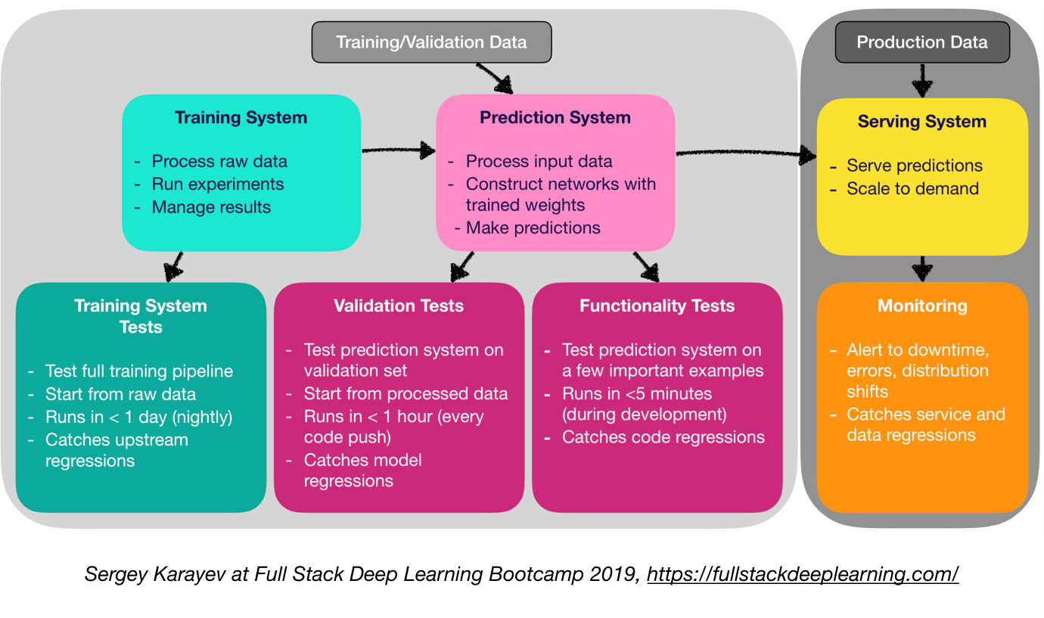

* Unit and Integration Testing:
  + Types of tests:
    - Training system tests: testing training pipeline
    - Validation tests: testing prediction system on validation set
    - Functionality tests: testing prediction system on few important examples
* Continuous Integration: Running tests after each new code change pushed to the repo
* SaaS for continuous integration:
  + [Argo](https://argoproj.github.io/): Open source Kubernetes native workflow engine for orchestrating parallel jobs (incudes workflows, events, CI and CD).
  + [CircleCI](https://circleci.com/): Language-Inclusive Support, Custom Environments, Flexible Resource Allocation, used by instacart, Lyft, and StackShare.
  + [Travis CI](https://travis-ci.org/)
  + [Buildkite](https://buildkite.com/): Fast and stable builds, Open source agent runs on almost any machine and architecture, Freedom to use your own tools and services
  + Jenkins: Old school build system

**4.2. Web Deployment**

* Consists of a **Prediction System** and a **Serving System**
  + Prediction System: Process input data, make predictions
  + Serving System (Web server):
    - Serve prediction with scale in mind
    - Use REST API to serve prediction HTTP requests
    - Calls the prediction system to respond
* Serving options:
  + - Deploy to VMs, scale by adding instances
    - Deploy as containers, scale via orchestration
    - Containers
      * Docker
    - Container Orchestration:
      * Kubernetes (the most popular now)
      * MESOS
      * Marathon
    1. Deploy code as a "serverless function"
    2. Deploy via a **model serving** solution
* Model serving:
  + Specialized web deployment for ML models
  + Batches request for GPU inference
  + Frameworks:
    - Tensorflow serving
    - MXNet Model server
    - Clipper (Berkeley)
    - SaaS solutions
      * [Seldon](https://www.seldon.io/): serve and scale models built in any framework on Kubernetes
      * [Algorithmia](https://algorithmia.com/)
* Decision making: CPU or GPU?
  + CPU inference:
    - CPU inference is preferable if it meets the requirements.
    - Scale by adding more servers, or going serverless.
  + GPU inference:
    - TF serving or Clipper
    - Adaptive batching is useful
* (Bonus) Deploying Jupyter Notebooks:
  + [Kubeflow Fairing](https://github.com/kubeflow/fairing) is a hybrid deployment package that let's you deploy your *Jupyter notebook* codes!

**4.5 Service Mesh and Traffic Routing**

* Transition from monolithic applications towards a distributed microservice architecture could be challenging.
* A **Service mesh** (consisting of a network of microservices) reduces the complexity of such deployments, and eases the strain on development teams.
  + [Istio](https://istio.io/): a service mesh to ease creation of a network of deployed services with load balancing, service-to-service authentication, monitoring, with few or no code changes in service code

**4.4. Monitoring:**

* Purpose of monitoring:
  + Alerts for downtime, errors, and distribution shifts
  + Catching service and data regressions
* Cloud providers solutions are decent
* [Kiali](https://kiali.io/):an observability console for Istio with service mesh configuration capabilities. It answers these questions: How are the microservices connected? How are they performing?

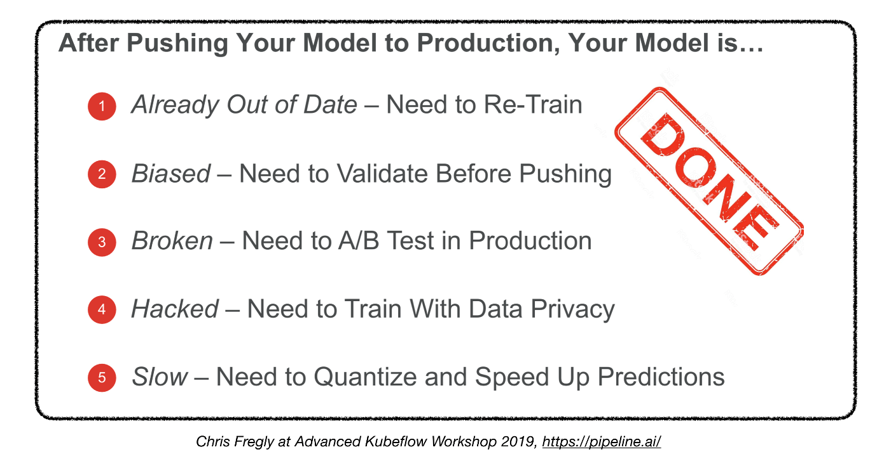

**4.5. Deploying on Embedded and Mobile Devices**

* Main challenge: memory footprint and compute constraints
* Solutions:
  + Quantization
  + Reduced model size
    - MobileNets
  + Knowledge Distillation
    - DistillBERT (for NLP)
* Embedded and Mobile Frameworks:
  + Tensorflow Lite
  + PyTorch Mobile
  + Core ML
  + ML Kit
  + FRITZ
  + OpenVINO
* Model Conversion:
  + Open Neural Network Exchange (ONNX): open-source format for deep learning models

**4.6. All-in-one solutions**

* Tensorflow Extended (TFX)
* Michelangelo (Uber)
* Google Cloud AI Platform
* Amazon SageMaker
* Neptune
* FLOYD
* Paperspace
* Determined AI
* Domino data lab

**Extra Read**

[**https://github.com/prakhargurawa/machine-learning-interview/blob/master/extra.md**](https://github.com/prakhargurawa/machine-learning-interview/blob/master/extra.md)



There are lot of sampling techniques which are grouped into two categories as

* Probability Sampling
* Non- Probability Sampling

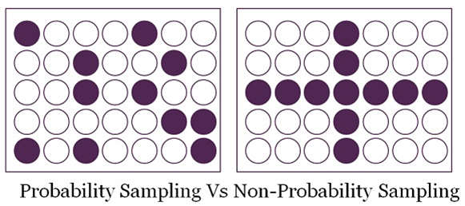

**Probability Sampling**

This Sampling technique uses randomization to make sure that every element of the population gets an equal chance to be part of the selected sample. It’s alternatively known as random sampling.

*Simple Random Sampling*

*Stratified sampling*

*Systematic sampling*

*Cluster Sampling*

*Multi stage Sampling*

**Non-Probability Sampling**

It does not rely on randomization. This technique is more reliant on the researcher’s ability to select elements for a sample. Outcome of sampling might be biased and makes difficult for all the elements of population to be part of the sample equally. This type of sampling is also known as non-random sampling.

*Convenience Sampling*

*Purposive Sampling*

*Quota Sampling*

*Referral /Snowball Sampling*

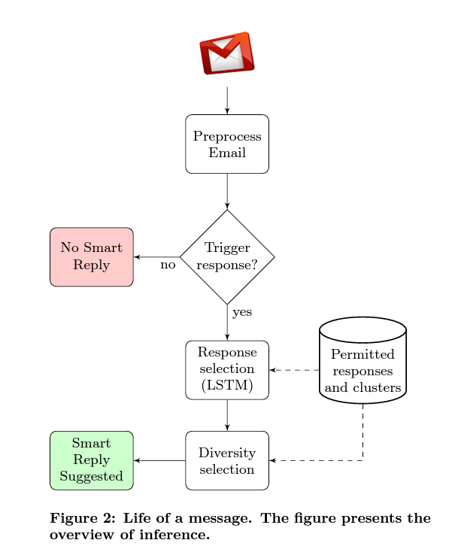

For example using RELU function is so much better than using SIGMOID function in training a NN because it helps with the vanishing gradient problem.

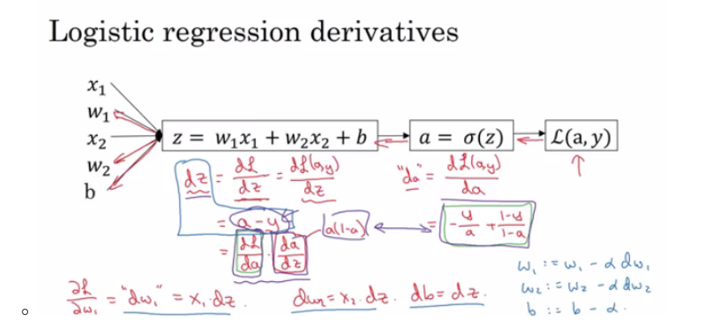

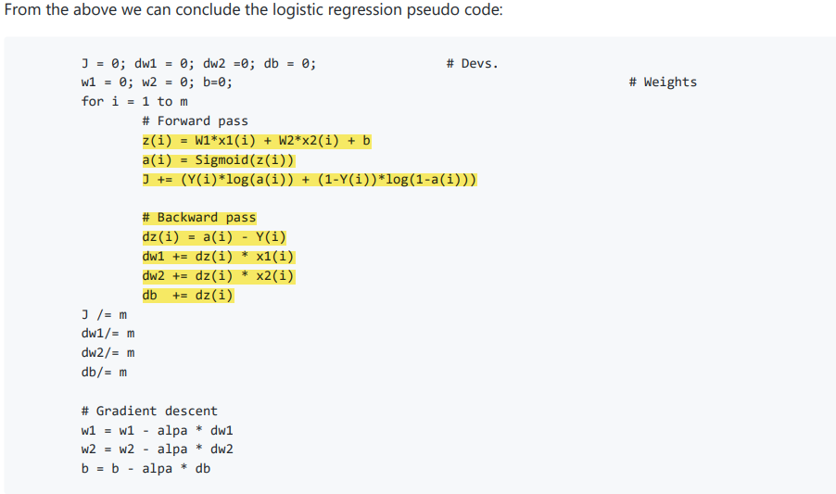

Sigmoid or Tanh function disadvantage is that if the input is too small or too high, the slope will be near zero which will cause us the gradient decent problem.

In Batch gradient descent we run the gradient descent on the whole dataset. While in Mini-Batch gradient descent we run the gradient descent on the mini datasets.

Mini-Batch algorithm pseudo code: for t = 1:No_of_batches # this is called an epoch AL, caches = forward_prop(X{t}, Y{t}) cost = compute_cost(AL, Y{t}) grads = backward_prop(AL, caches) update_parameters(grads)

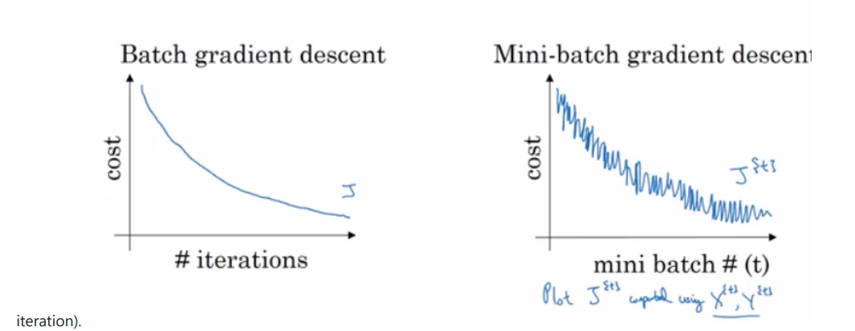

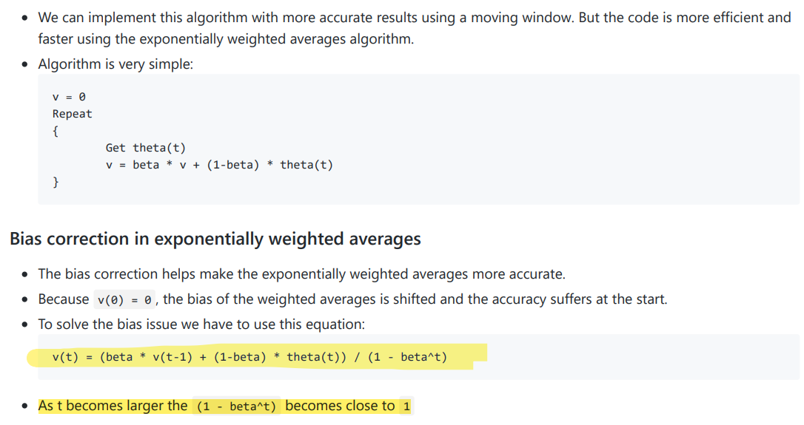

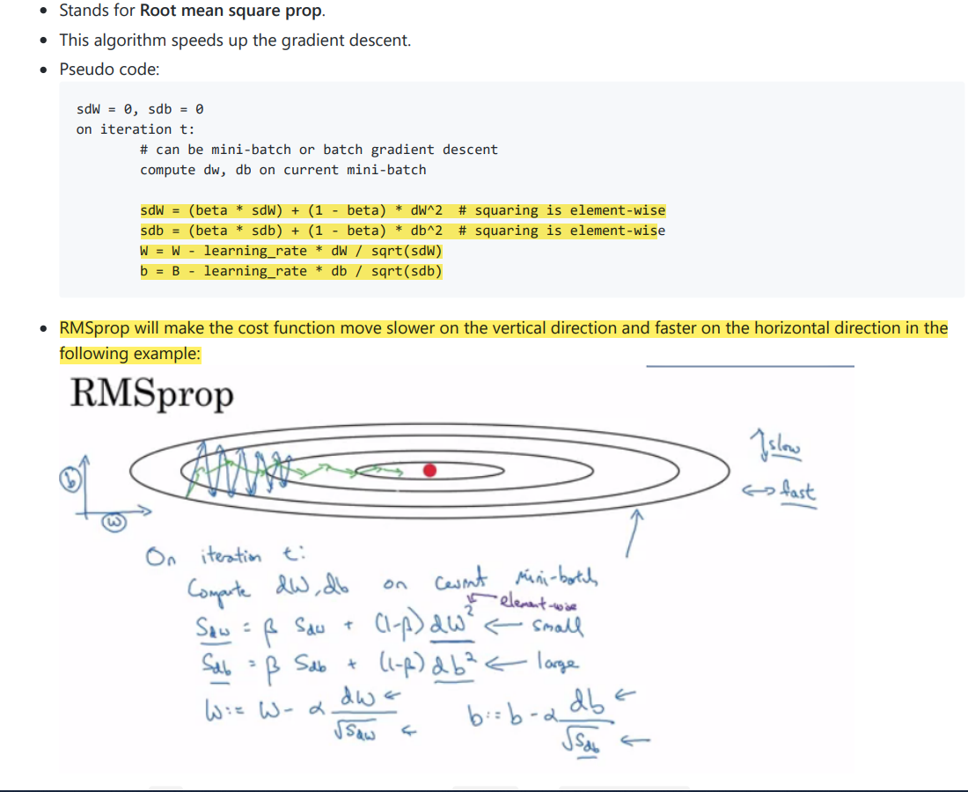

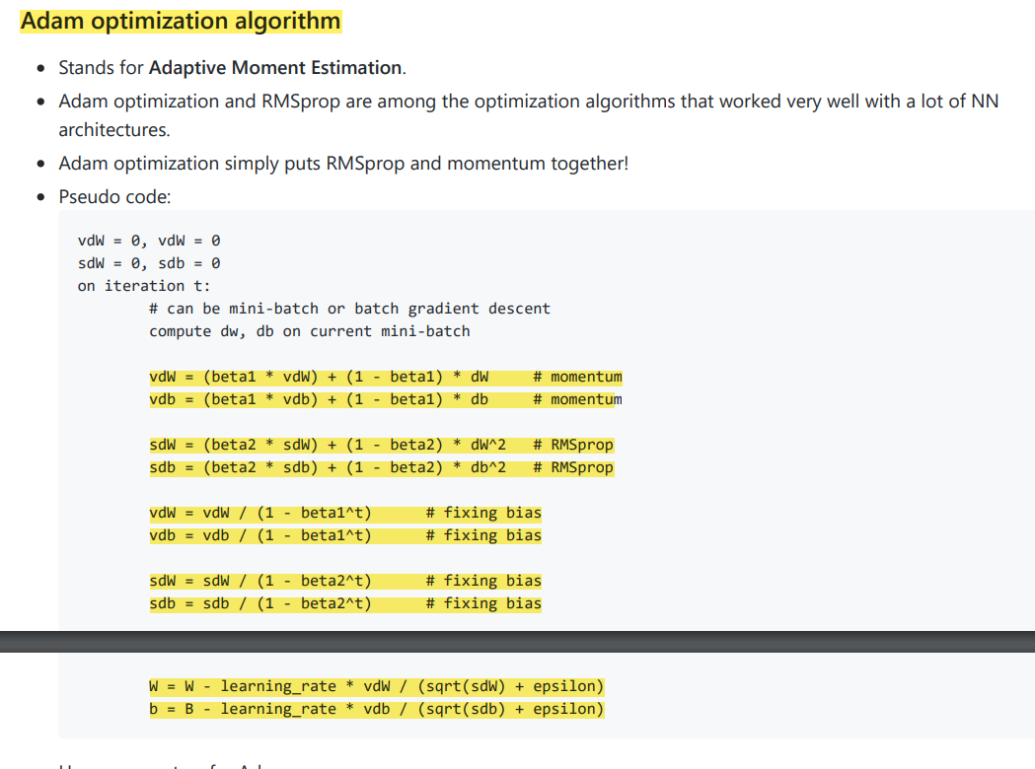

Why does Batch normalization work? The first reason is the same reason as why we normalize X. The second reason is that batch normalization reduces the problem of input values changing (shifting). Batch normalization does some regularization: Each mini batch is scaled by the mean/variance computed of that mini-batch. This adds some noise to the values Z[l] within that mini batch. So similar to dropout it adds some noise to each hidden layer's activations. This has a slight regularization effect. Using bigger size of the mini-batch you are reducing noise and therefore regularization effect. Don't rely on batch normalization as a regularization. It's intended for normalization of hidden units, activations and therefore speeding up learning. For regularization use other regularization techniques (L2 or dropout).

Batch Normalization speeds up learning. Before we normalized input by subtracting the mean and dividing by variance. This helped a lot for the shape of the cost function and for reaching the minimum point faster.

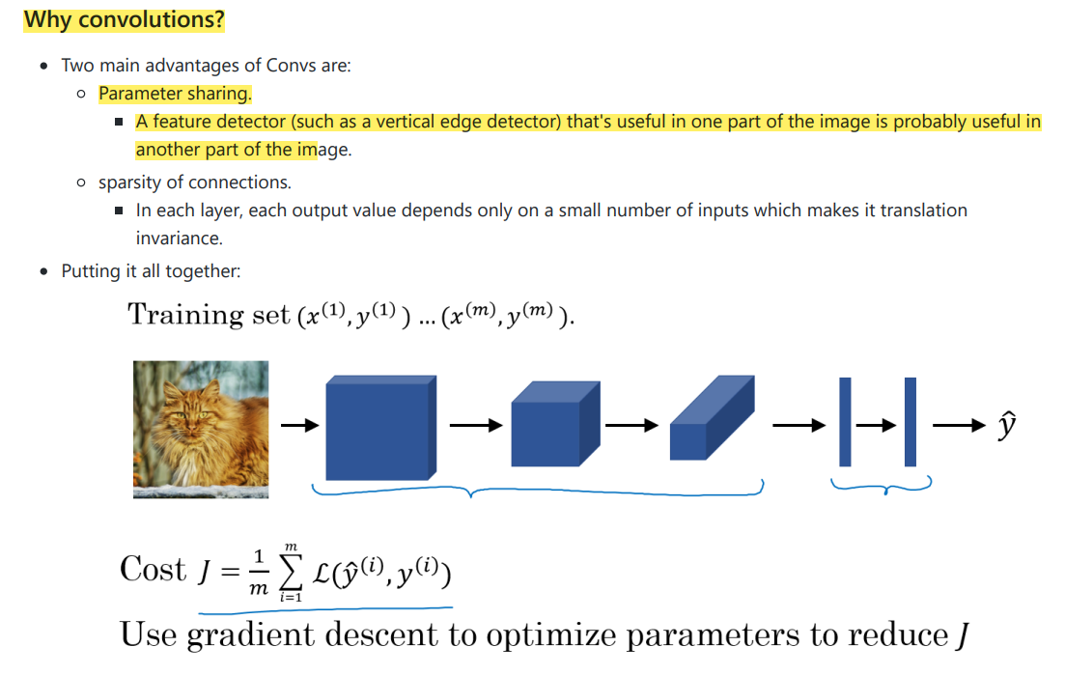

Residual Networks (ResNets) Very, very deep NNs are difficult to train because of vanishing and exploding gradients problemsa

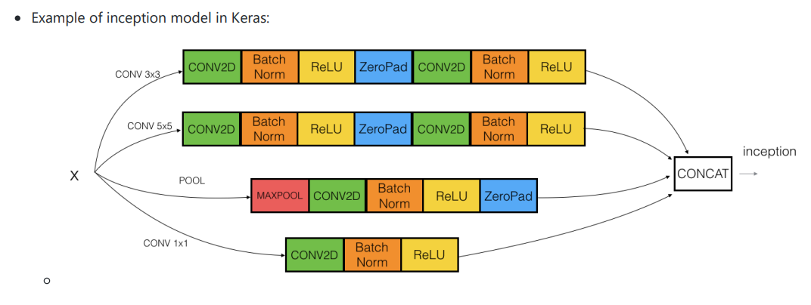

Some data augmentation methods that are used for computer vision tasks includes: Mirroring. Random cropping. The issue with this technique is that you might take a wrong crop. The solution is to make your crops big enough. Rotation. Shearing. Local warping. Color shifting. For example, we add to R, G, and B some distortions that will make the image identified as the same for the human but is different for the computer. In practice the added value are pulled from some probability distribution and these shifts are some small. Makes your algorithm more robust in changing colors in images. There are an algorithm which is called PCA color augmentation that decides the shifts needed automatically.

Create->Compile->Fit/Train->Evaluate/Test

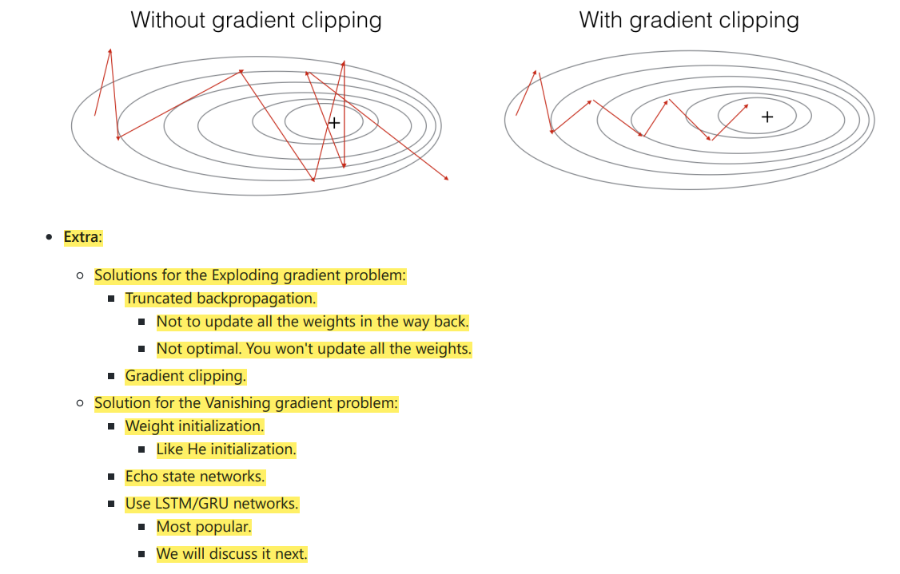

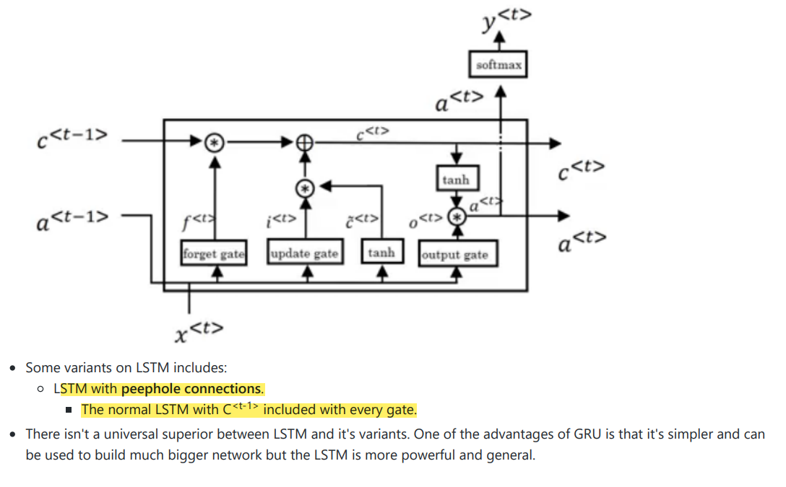

In practice, the hierarchical softmax classifier doesn't use a balanced tree like the drawn one. Common words are at the top and less common are at the bottom.

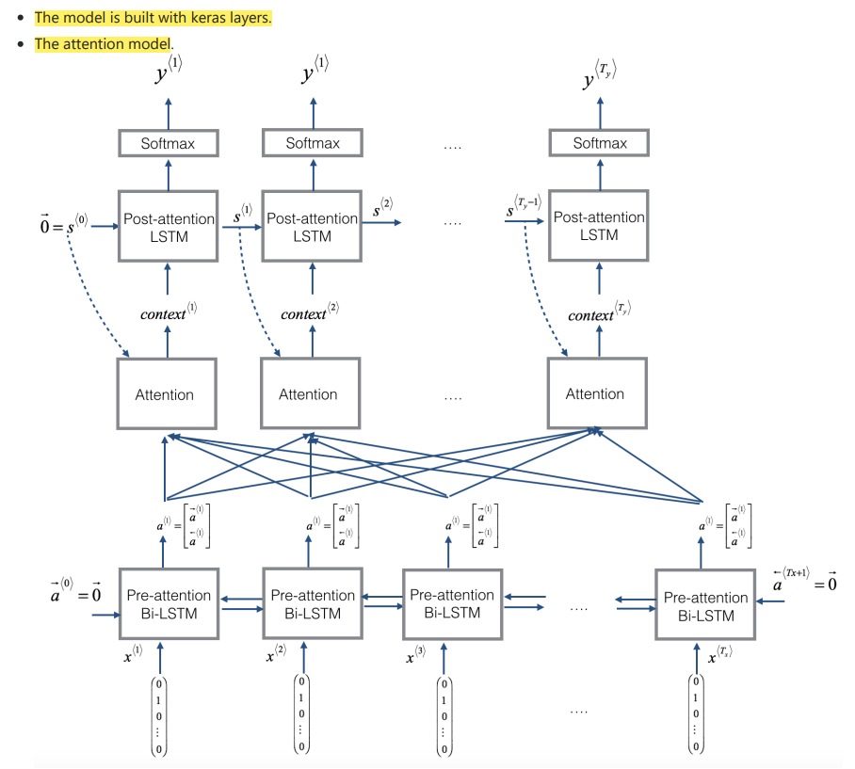

*#Find the maximum and minimum grayscale values in this image*

max_val **=** np**.**amax(gray_image)

min_val **=** np**.**amin(gray_image)

print('Max: ', max_val)

print('Min: ', min_val)

sobel_my **=** np**.**array([[ 0, **-**1, 0],

[ **-**1, 4, **-**1],

[ 0, **-**1, 0]])

*# Create threshold that sets all the filtered pixels to white*

*# Above a certain threshold*

retval, binary_image **=** cv2**.**threshold(filtered_blurred, 50, 255, cv2**.**THRESH_BINARY)

plt**.**imshow(binary_image, cmap**=**'gray')

line_image **=** np**.**copy(image) *#creating an image copy to draw lines on*

*# Run Hough on the edge-detected image*

lines **=** cv2**.**HoughLinesP(edges, rho, theta, threshold, np**.**array([]),

min_line_length, max_line_gap)

*## TODO: Complete this function so that*

*## it returns a new, cropped version of the original image*

**def** left_hand_crop(image, selected_contour):

"""

Left hand crop

:param image: the original image

:param selectec_contour: the contour that will be used for cropping

:return: cropped_image, the cropped image around the left hand

"""

*## TODO: Detect the bounding rectangle of the left hand contour*

*## TODO: Crop the image using the dimensions of the bounding rectangle*

*# Make a copy of the image to crop*

cropped_image **=** np**.**copy(image)

x,y,w,h **=** cv2**.**boundingRect(selected_contour)

box_image **=** cv2**.**rectangle(contours_image, (x,y), (x**+**w,y**+**h), (200,0,200),2)

cropped_image **=** image[y: y **+** h, x: x **+** w]

**return** cropped_image

*## TODO: Select a value for k*

*# then perform k-means clustering*

k **=** 2

retval, labels, centers **=** cv2**.**kmeans(pixel_vals, k, **None**, criteria, 10, cv2**.**KMEANS_RANDOM_CENTERS)

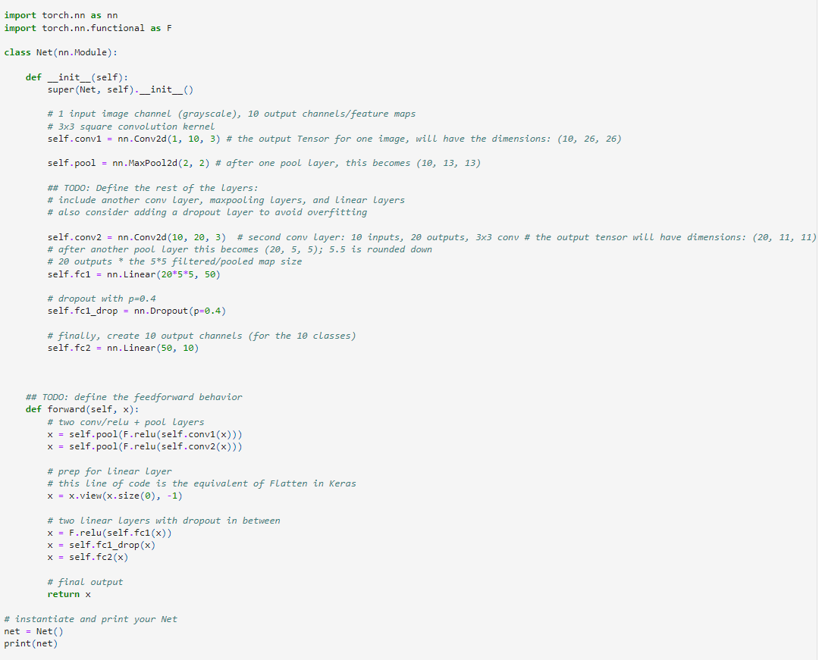

## LSTMs in Pytorch

To create and train an LSTM, you have to know how to structure the inputs, and hidden state of an LSTM. In PyTorch an LSTM can be defined as: lstm = nn.LSTM(input_size=input_dim, hidden_size=hidden_dim, num_layers=n_layers).

In PyTorch, an LSTM expects all of its inputs to be 3D tensors, with dimensions defined as follows:

* input_dim = the number of inputs (a dimension of 20 could represent 20 inputs)
* hidden_dim = the size of the hidden state; this will be the number of outputs that each LSTM cell produces at each time step.
* n_layers = the number of hidden LSTM layers to use; this is typically a value between 1 and 3; a value of 1 means that each LSTM cell has one hidden state. This has a default value of 1.

|  |
| --- |
| class EncoderCNN(nn.Module): |
|  | def __init__(self, embed_size): |
|  | super(EncoderCNN, self).__init__() |
|  | resnet = models.resnet50(pretrained=True) |
|  | for param in resnet.parameters(): |
|  | param.requires_grad_(False) |
|  |  |
|  | modules = list(resnet.children())[:-1] |
|  | self.resnet = nn.Sequential(*modules) |
|  | self.embed = nn.Linear(resnet.fc.in_features, embed_size) |
|  |  |
|  | def forward(self, images): |
|  | features = self.resnet(images) |
|  | features = features.view(features.size(0), -1) |
|  | features = self.embed(features) |
|  | return features |
|  |  |
|  |  |
|  | class DecoderRNN(nn.Module): |
|  | def __init__(self, embed_size, hidden_size, vocab_size, num_layers=1): |
|  | super(DecoderRNN, self).__init__() |
|  | self.embedding = nn.Embedding(vocab_size, embed_size) |
|  | self.lstm = nn.LSTM(embed_size, hidden_size, num_layers, batch_first = True) |
|  | self.fc = nn.Linear(hidden_size, vocab_size) |
|  |  |
|  | def forward(self, features, captions): |
|  | captions = captions[:, :-1] |
|  | embed = self.embedding(captions) |
|  | embed = torch.cat((features.unsqueeze(1), embed), dim = 1) |
|  | lstm_outputs, _ = self.lstm(embed) |
|  | output = self.fc(lstm_outputs) |
|  | return output |
|  |  |
|  | def sample(self, inputs, states=None, max_len=20): |
|  | " accepts pre-processed image tensor (inputs) and returns predicted sentence (list of tensor ids of length max_len) " |
|  | tensor_tokens = [] |
|  | for i in range(max_len): |
|  | out, states = self.lstm(inputs, states) |
|  | out = self.fc(out.squeeze(1)) |
|  | _, predicted = out.max(1) |
|  | tensor_tokens.append(predicted.item()) |
|  | inputs = self.embedding(predicted) |
|  | inputs = inputs.unsqueeze(1) |
|  | return tensor_tokens |

**Neo4j**

Neo4j is written in Java Language

* **ACID properties** − Neo4j supports full ACID (Atomicity, Consistency, Isolation, and Durability) rules.
* Labels
* Label associates a common name to a set of nodes or relationships. A node or relationship can contain one or more labels. We can create new labels to existing nodes or relationships. We can remove the existing labels from the existing nodes or relationships
* CREATE (node1)-[:RelationshipType]->(node2)

The library contains implementations for the following types of algorithms:

* [**Path Finding**](https://neo4j.com/docs/graph-data-science/current/algorithms/pathfinding/) - these algorithms help find the shortest path or evaluate the availability and quality of routes
* [**Centrality**](https://neo4j.com/docs/graph-data-science/current/algorithms/centrality/) - these algorithms determine the importance of distinct nodes in a network
* [**Community Detection**](https://neo4j.com/docs/graph-data-science/current/algorithms/community/) - these algorithms evaluate how a group is clustered or partitioned, as well as its tendency to strengthen or break apart
* [**Similarity**](https://neo4j.com/docs/graph-data-science/current/algorithms/similarity/) - these algorithms help calculate the similarity of nodes
* [**Topological link prediction**](https://neo4j.com/docs/graph-data-science/current/algorithms/linkprediction/) - these algorithms determine the closeness of pairs of nodes
* [**Node Embeddings**](https://neo4j.com/docs/graph-data-science/current/algorithms/node-embeddings/) - these algorithms compute vector representations of nodes in a graph.
* [**Node Classification**](https://neo4j.com/docs/graph-data-science/current/algorithms/ml-models/node-classification/) - this algorithm uses machine learning to predict the classification of nodes.
* [**Link prediction**](https://neo4j.com/docs/graph-data-science/current/algorithms/ml-models/linkprediction/) - these algorithms use machine learning to predict new links between pairs of nodes
* Cypher Query Language
* Cypher is Neo4j’s graph query language that lets you retrieve data from the graph. It is like SQL for graphs, and was inspired by SQL so it lets you focus on what data you want out of the graph (not how to go get it). It is the easist graph language to learn by far because of its similarity to other languages, and intuitiveness.

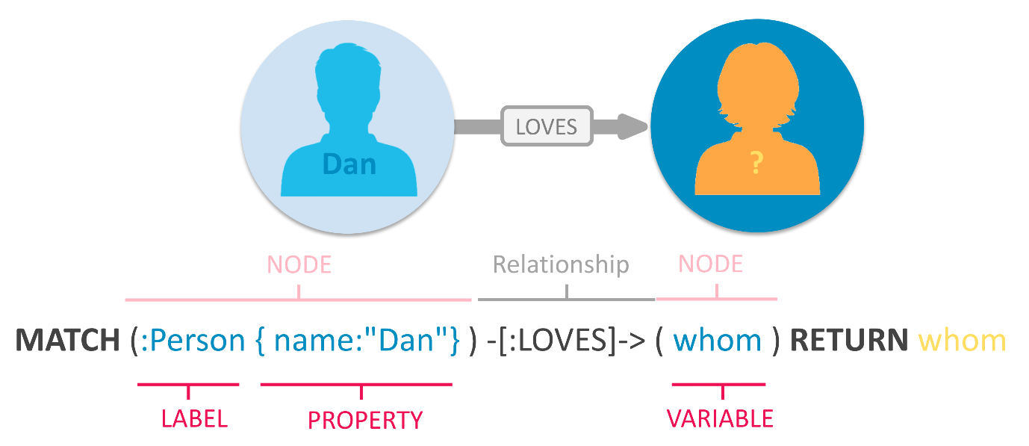

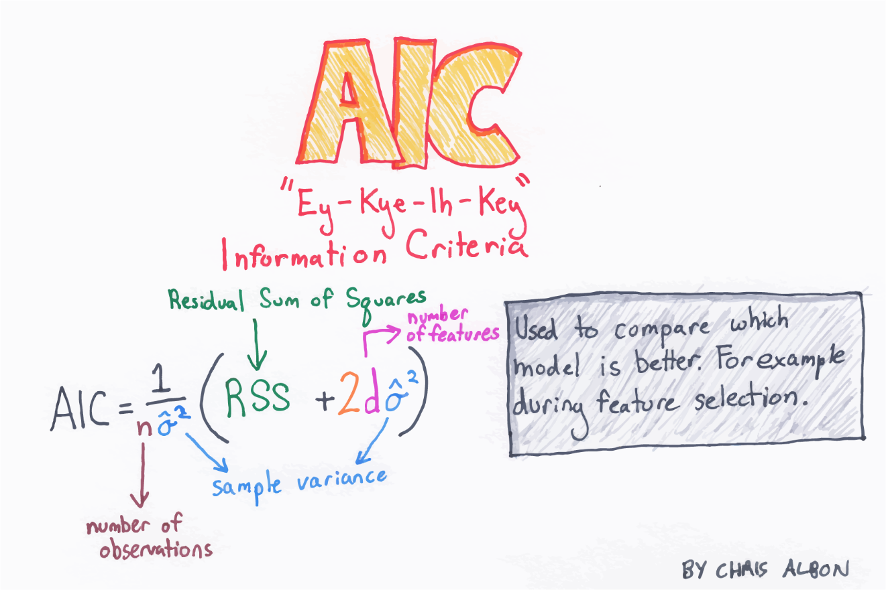

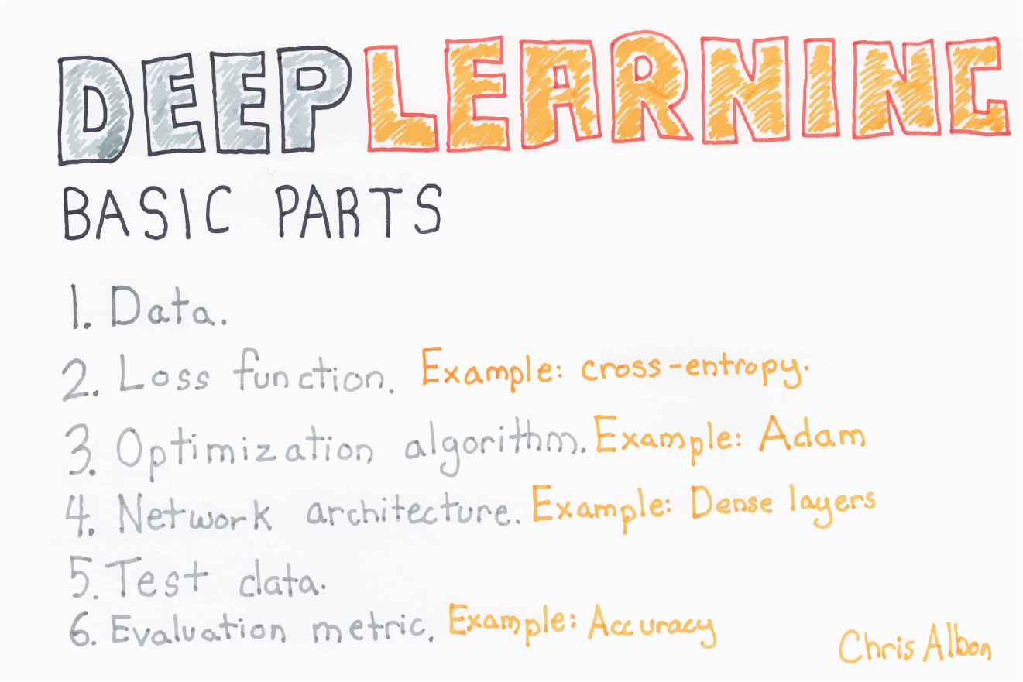

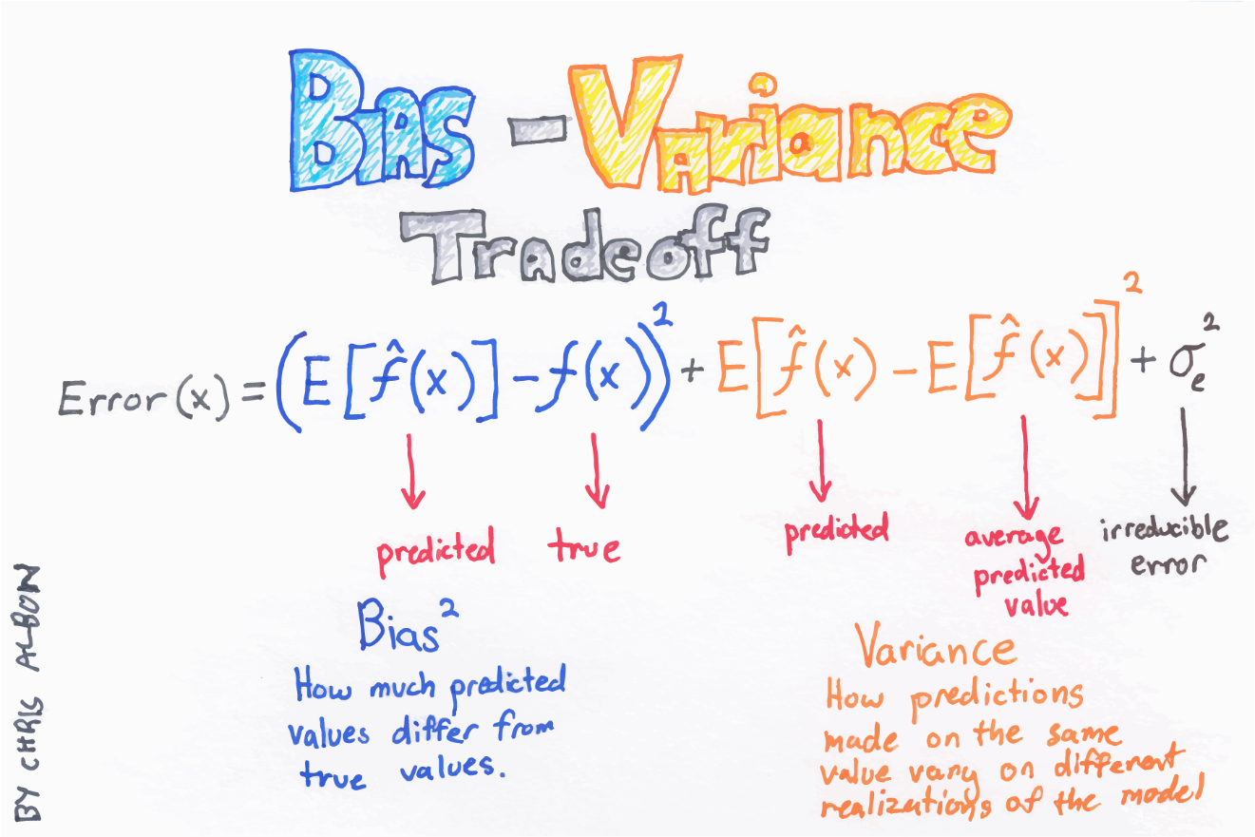

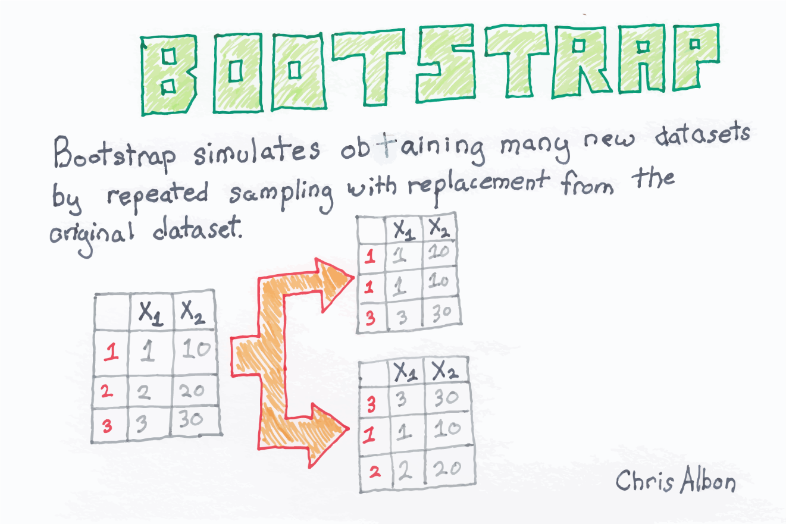

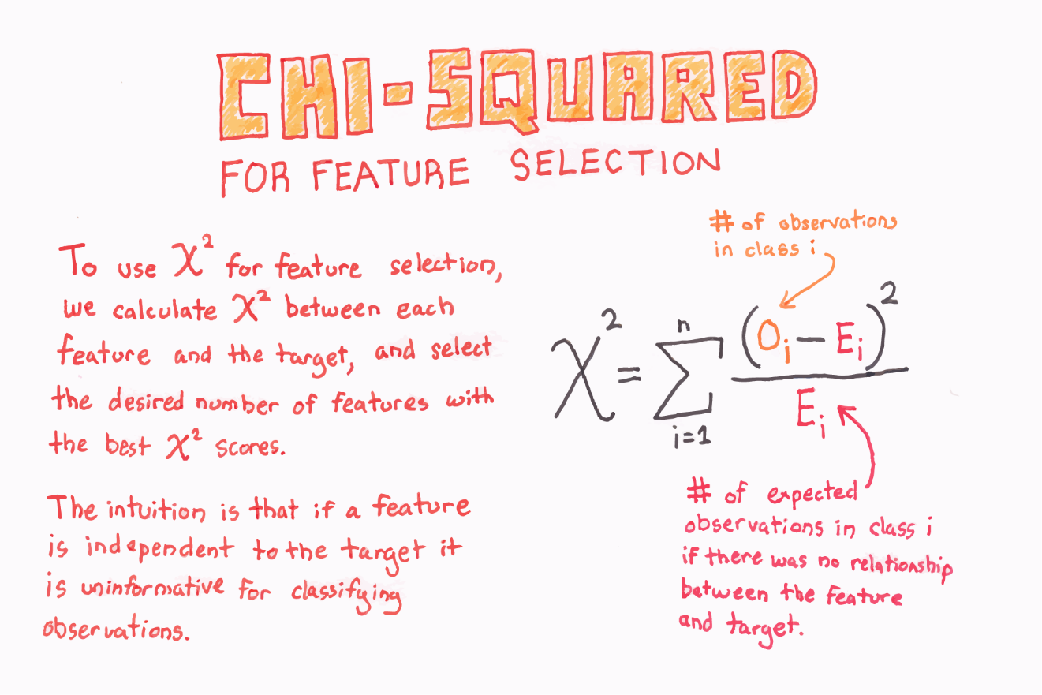

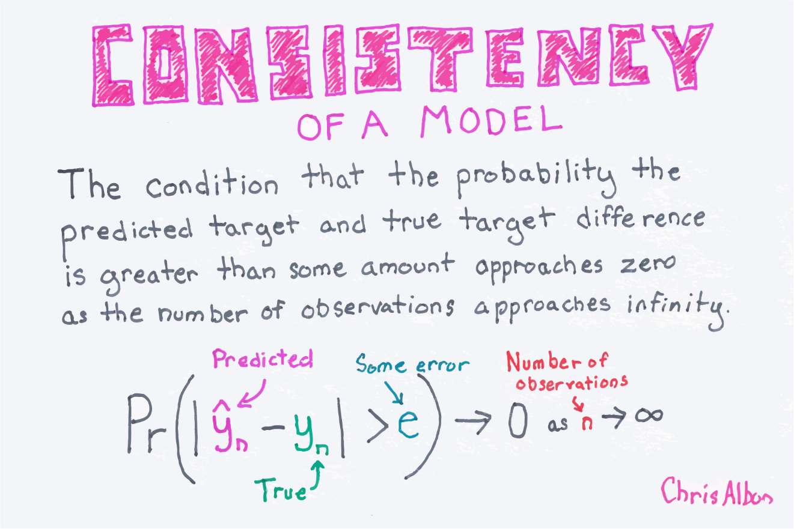

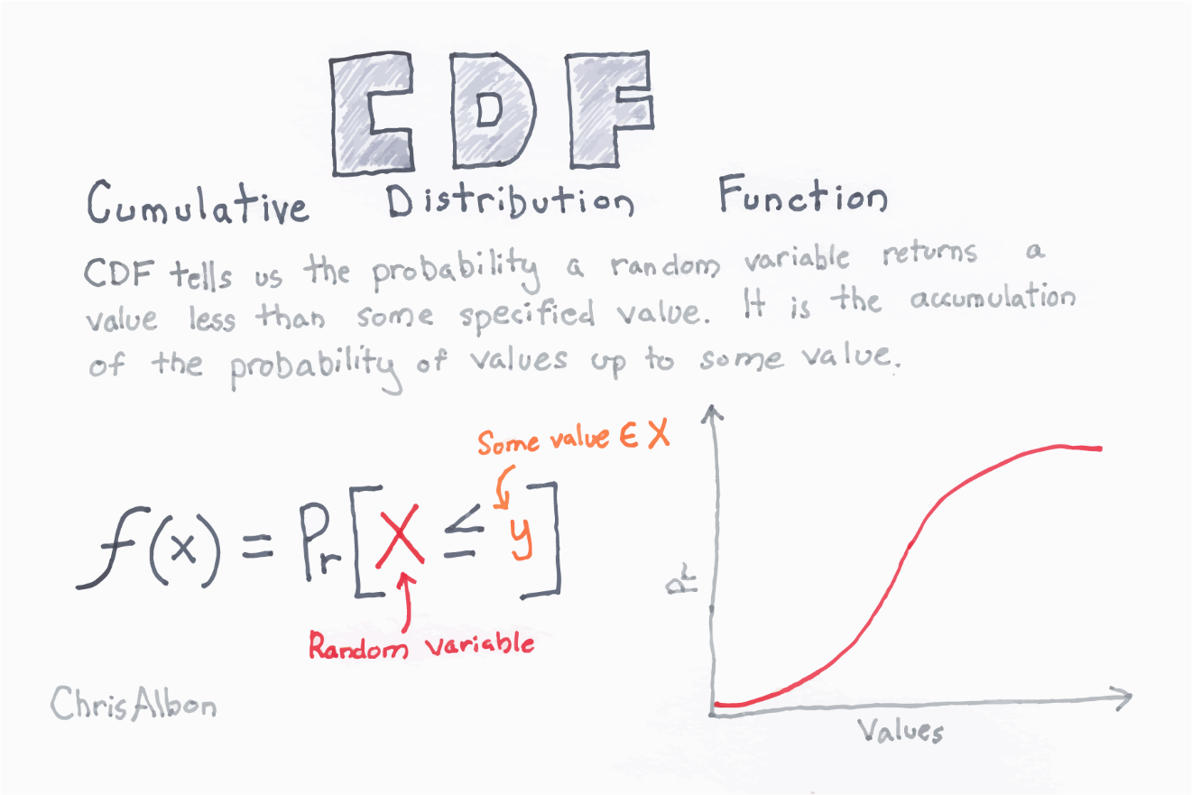

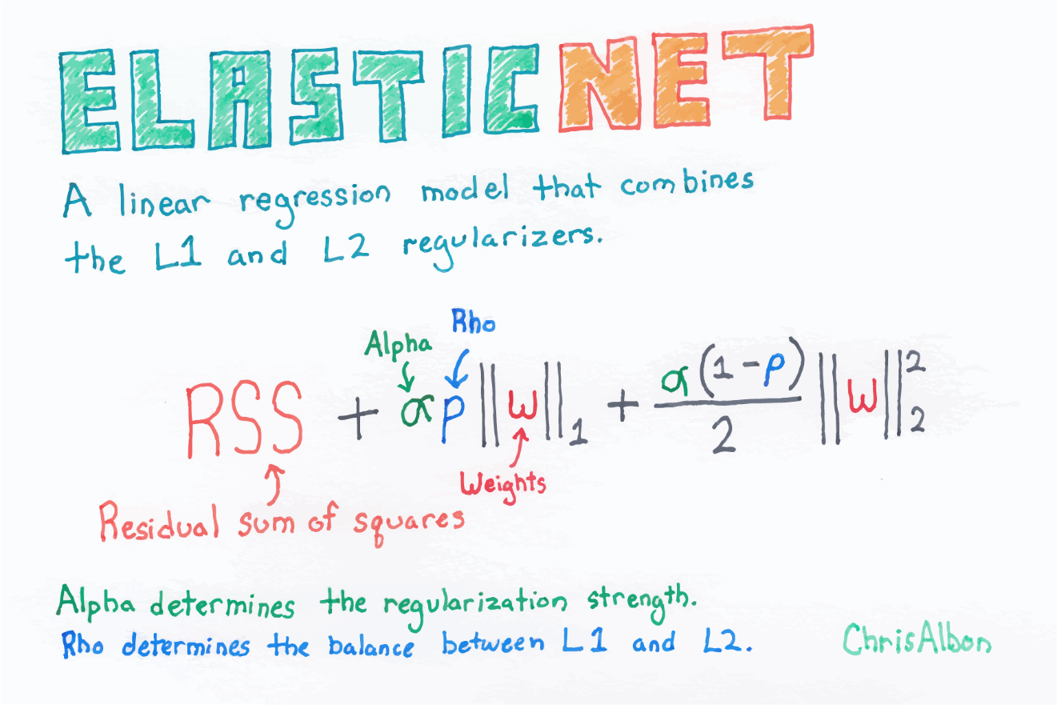

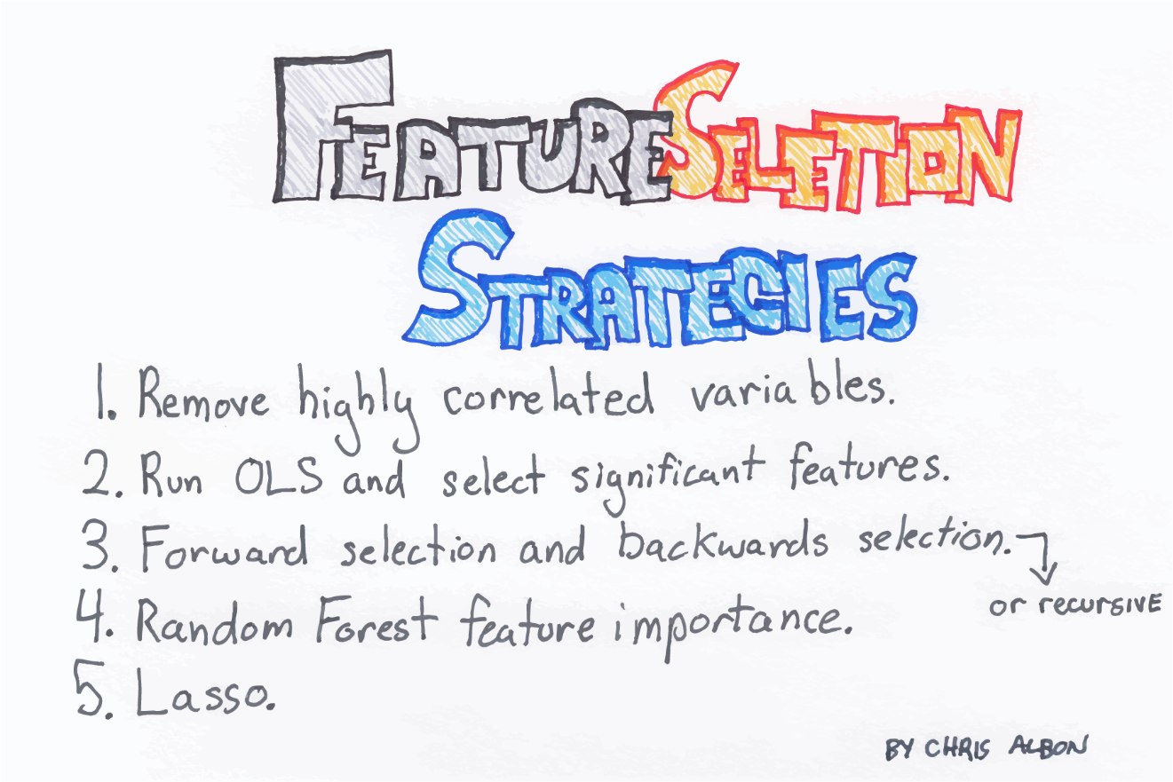

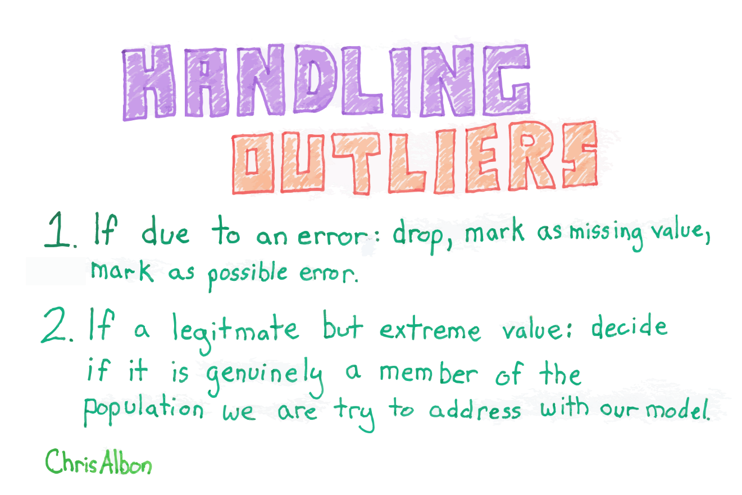

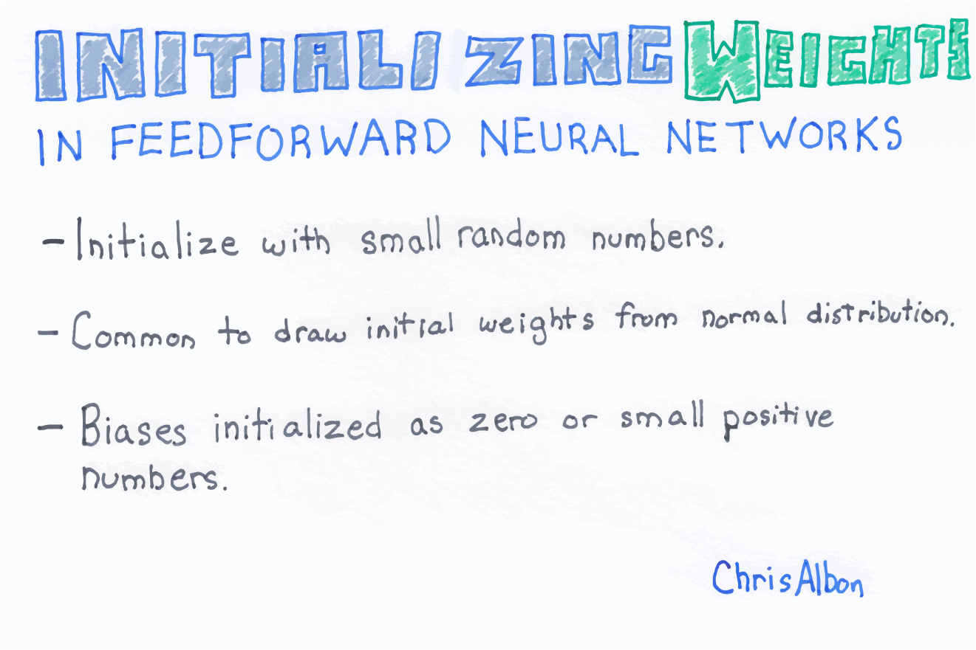

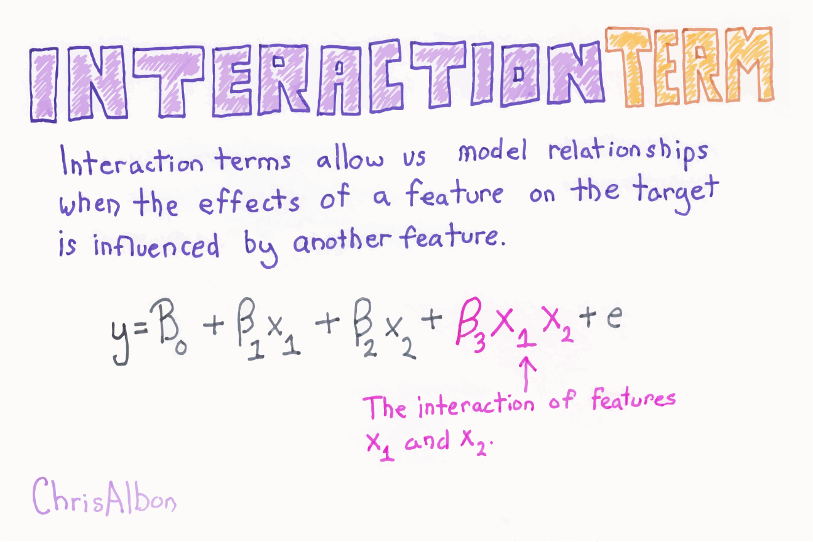

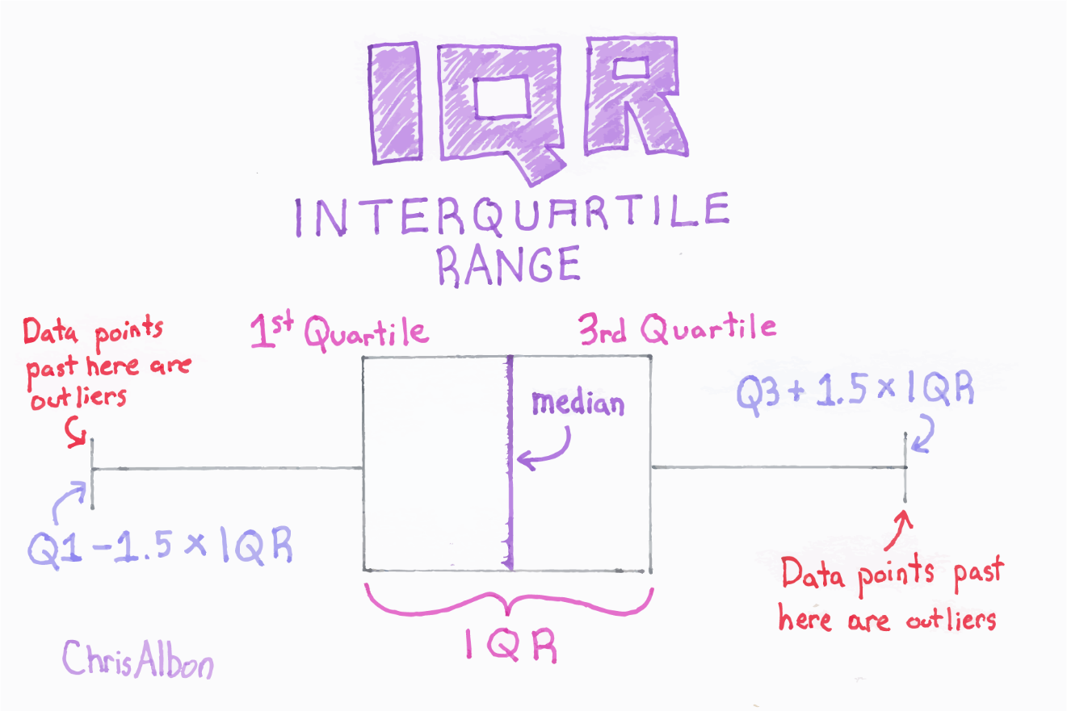

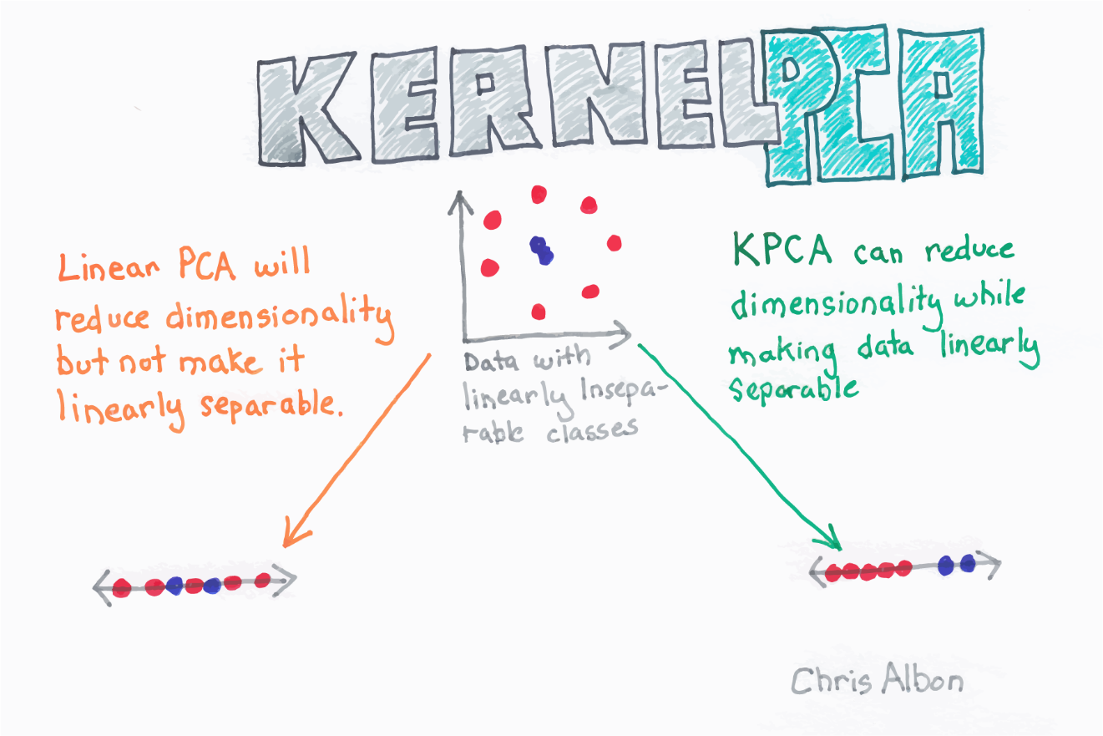

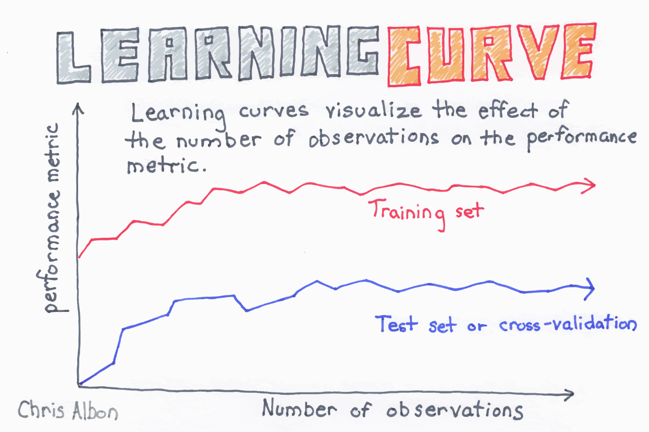

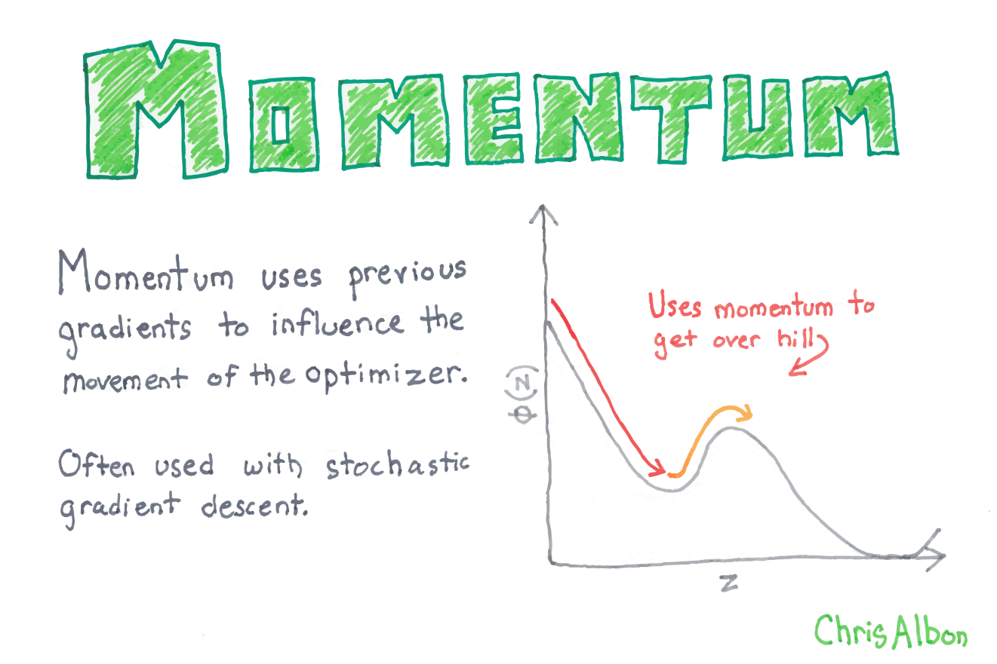

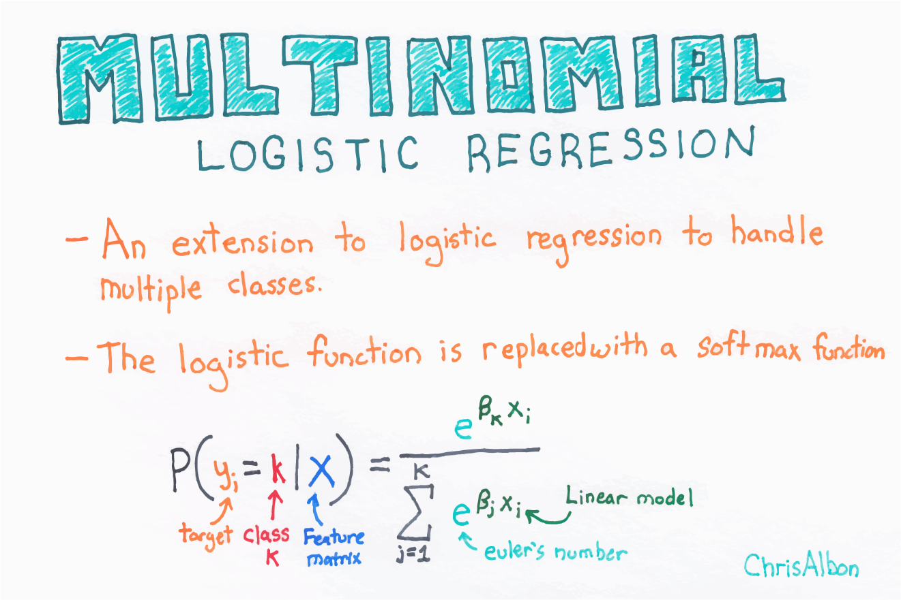

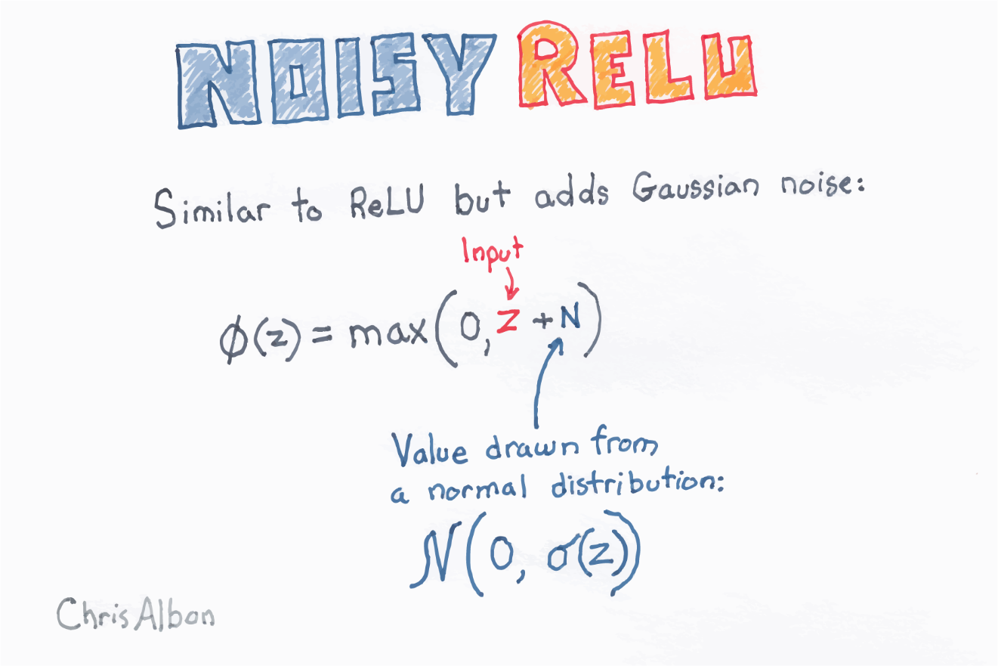

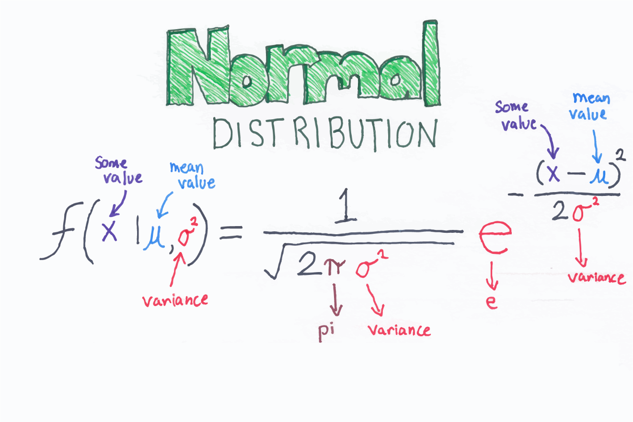

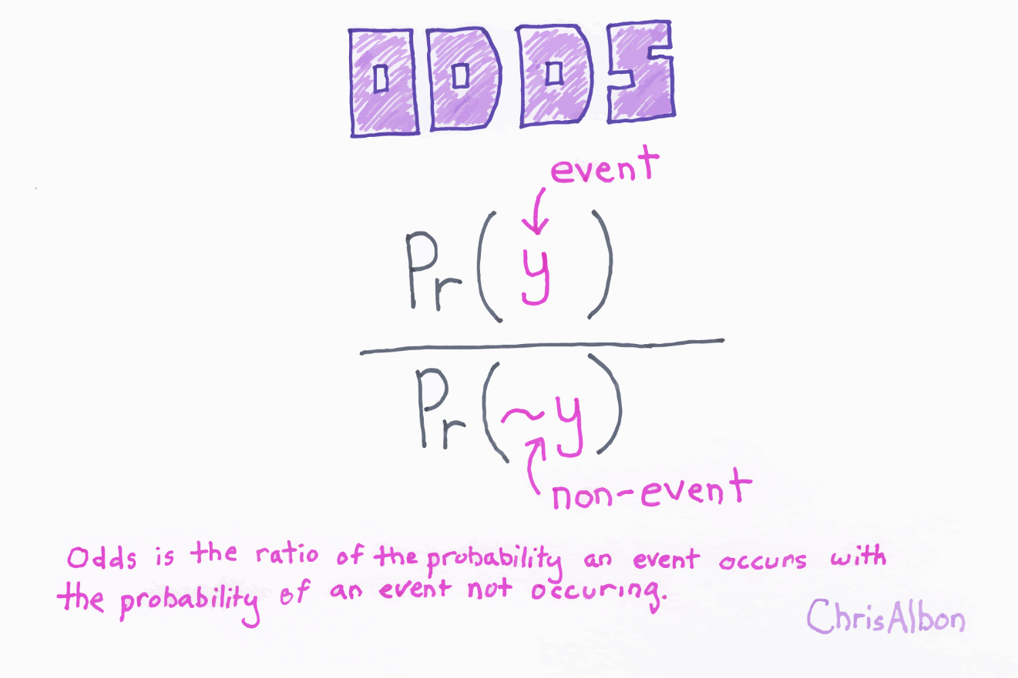

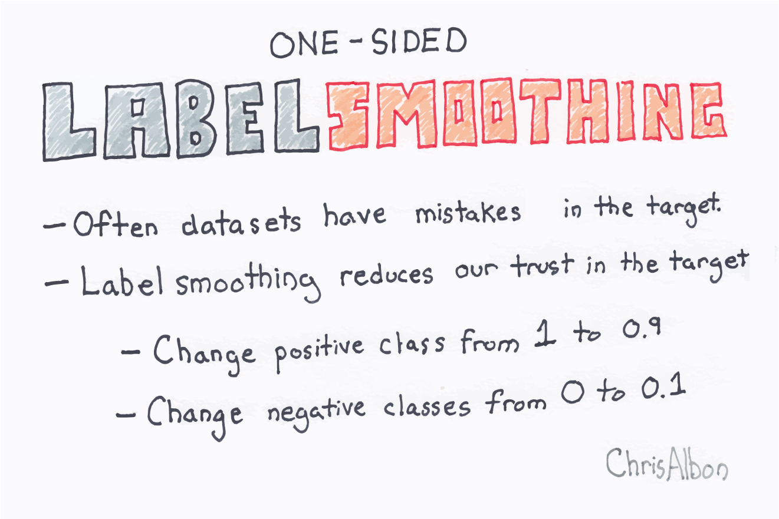

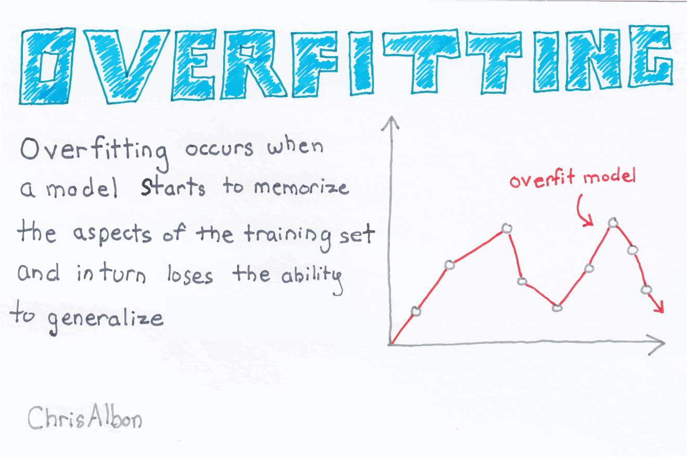

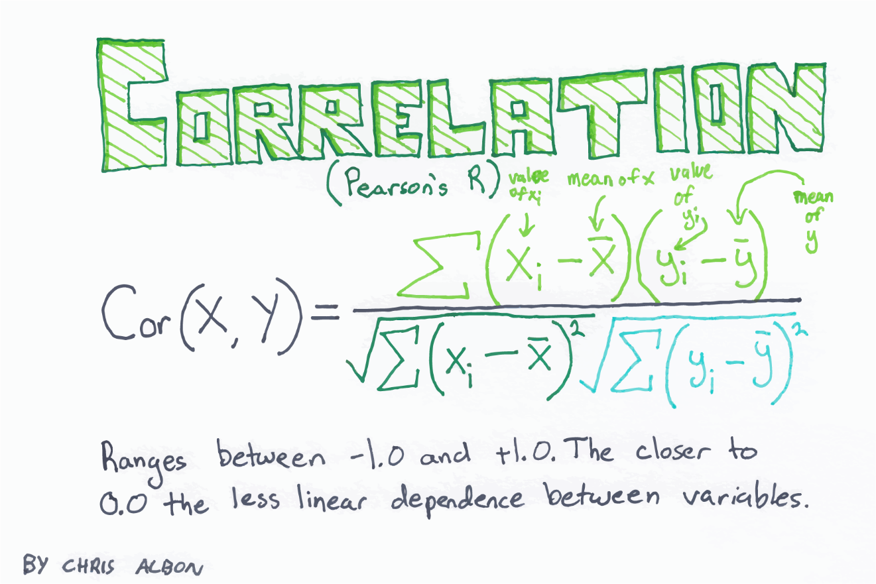

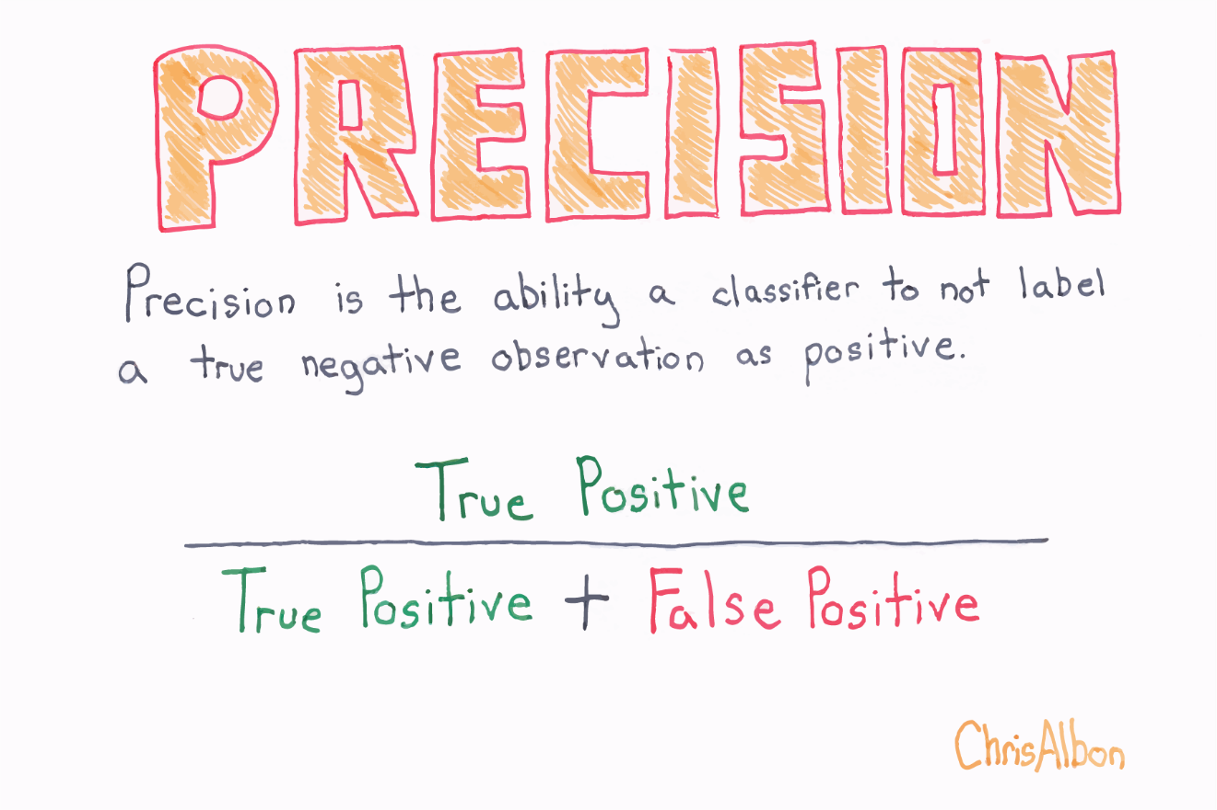

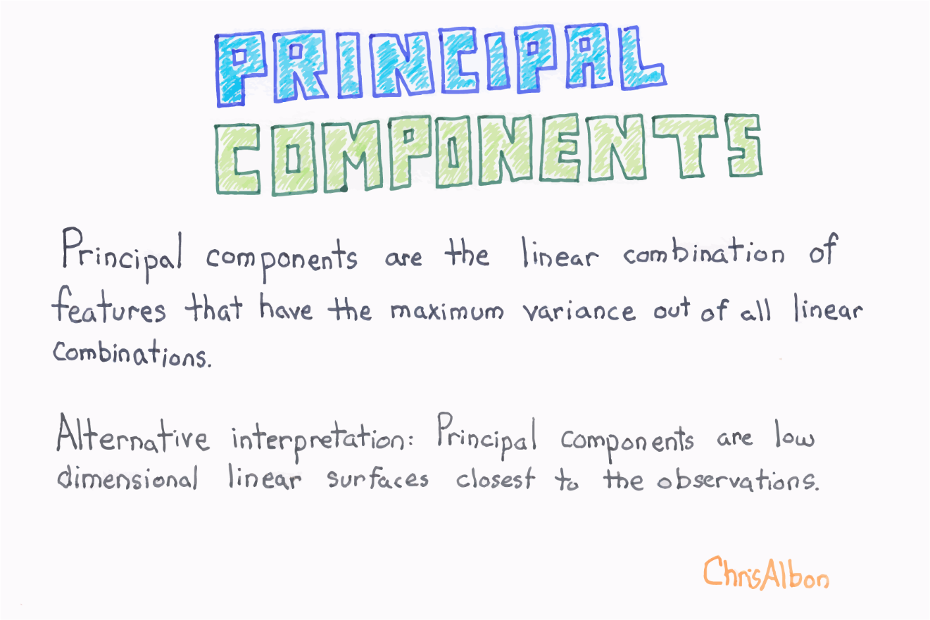

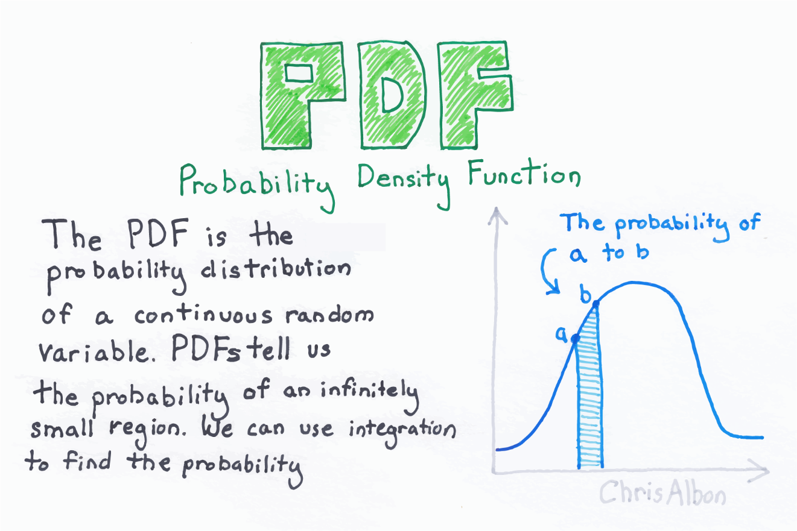

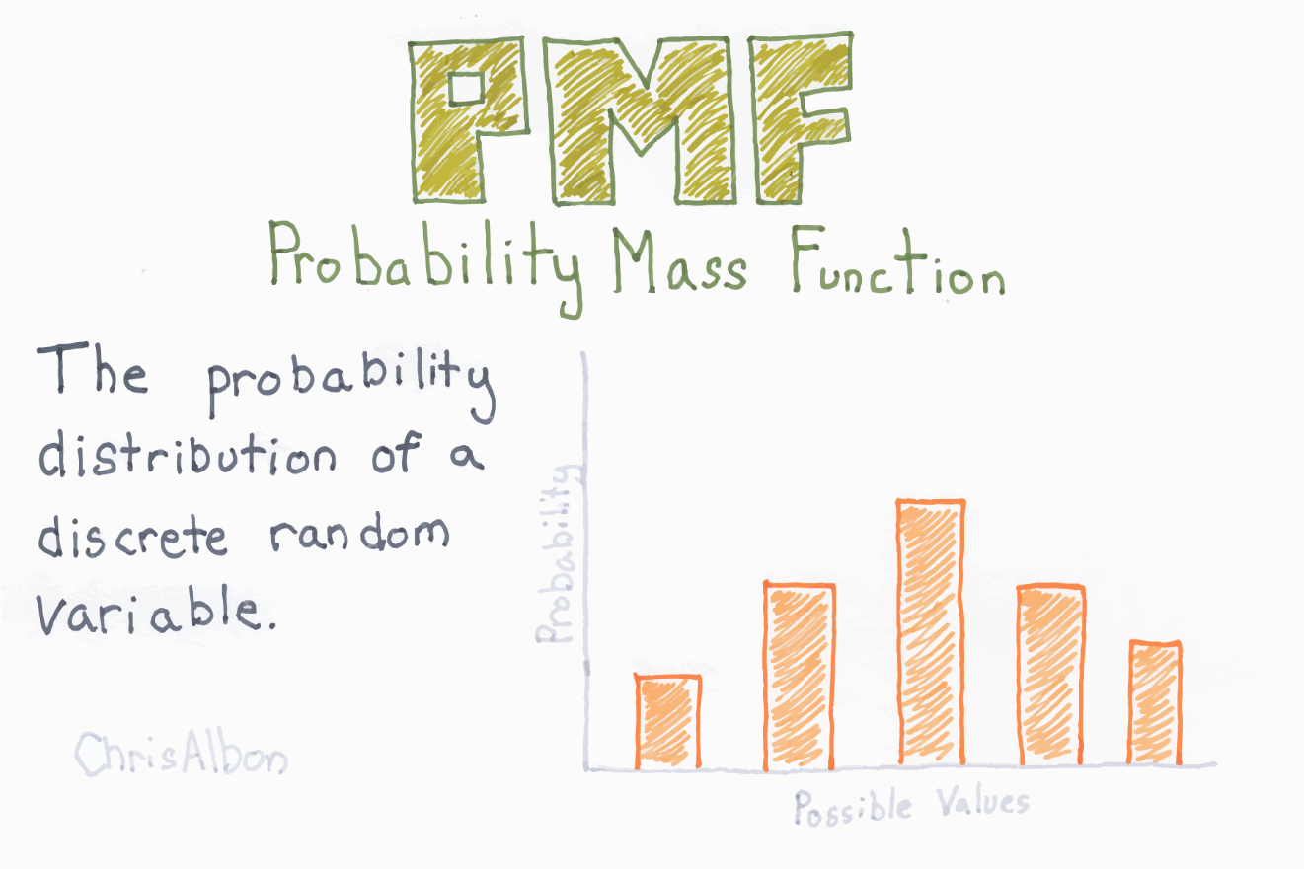

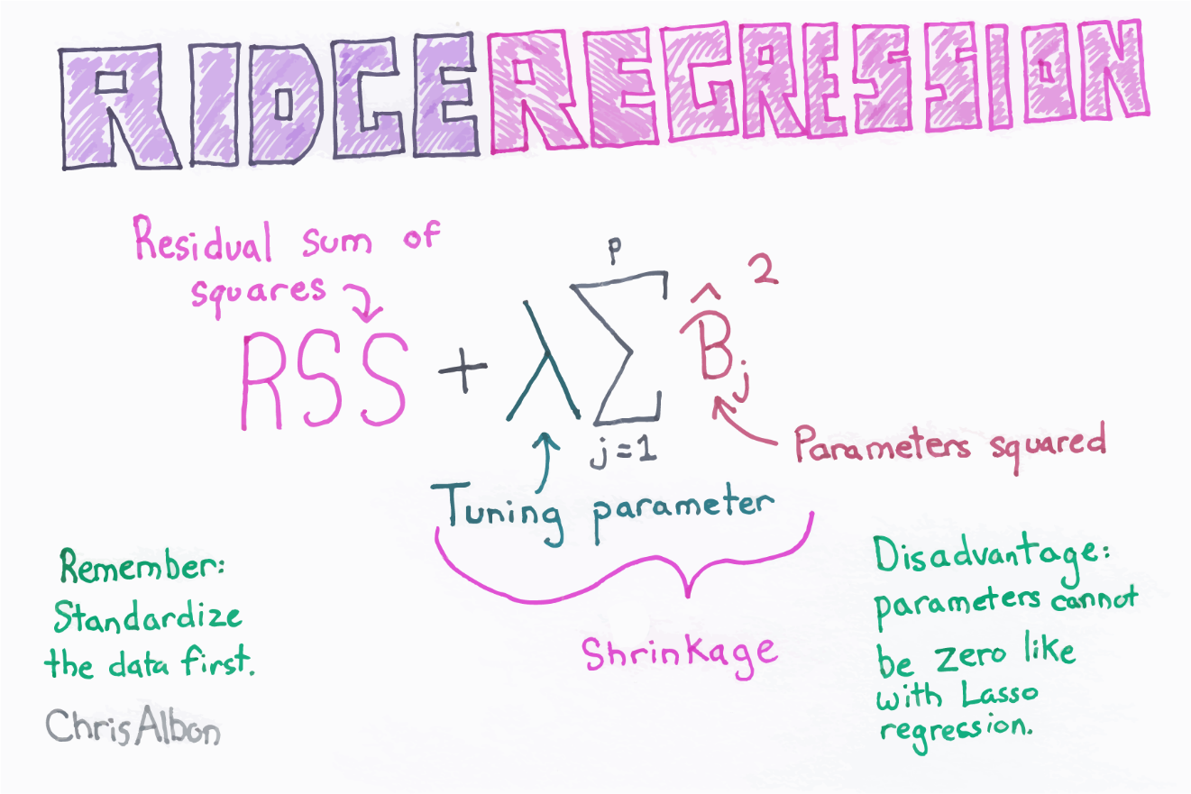

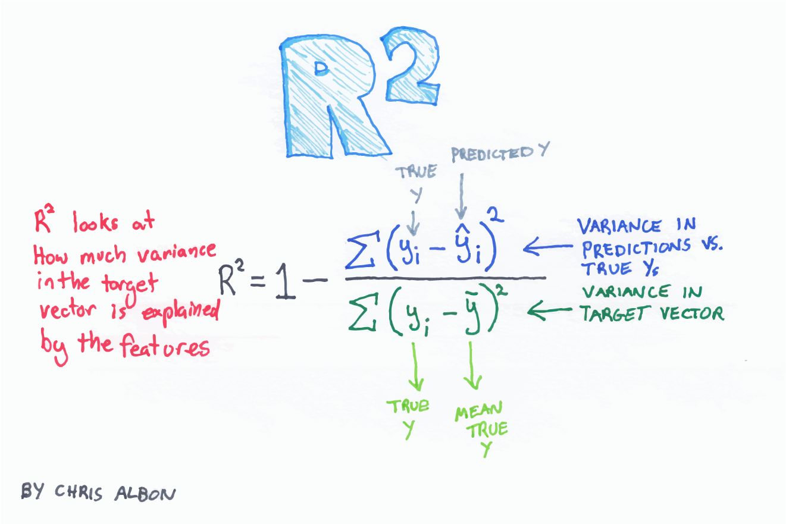

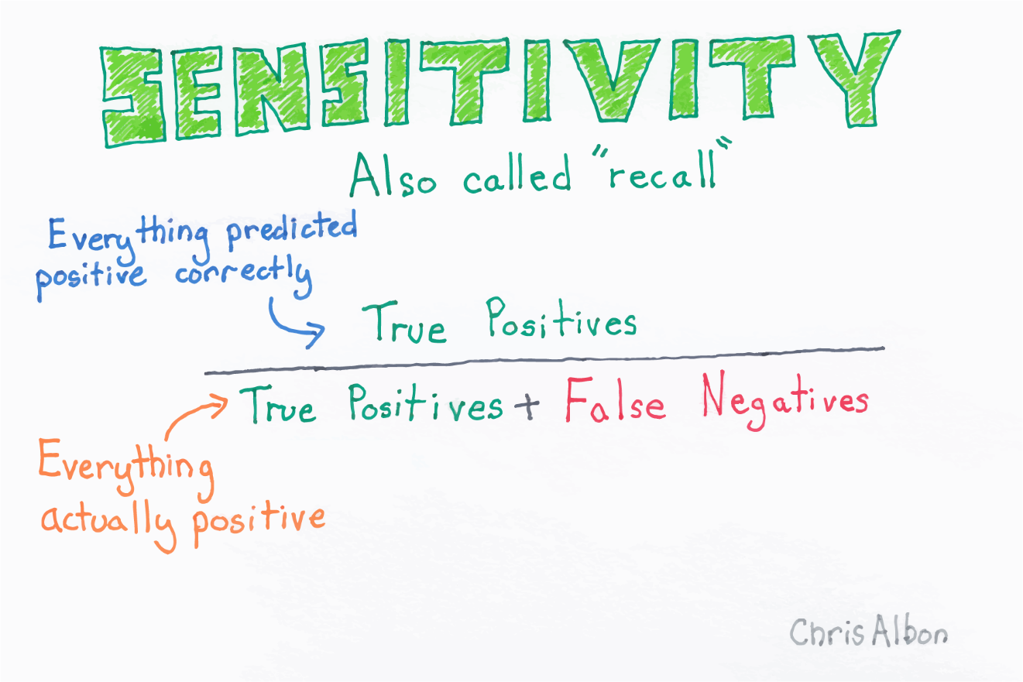

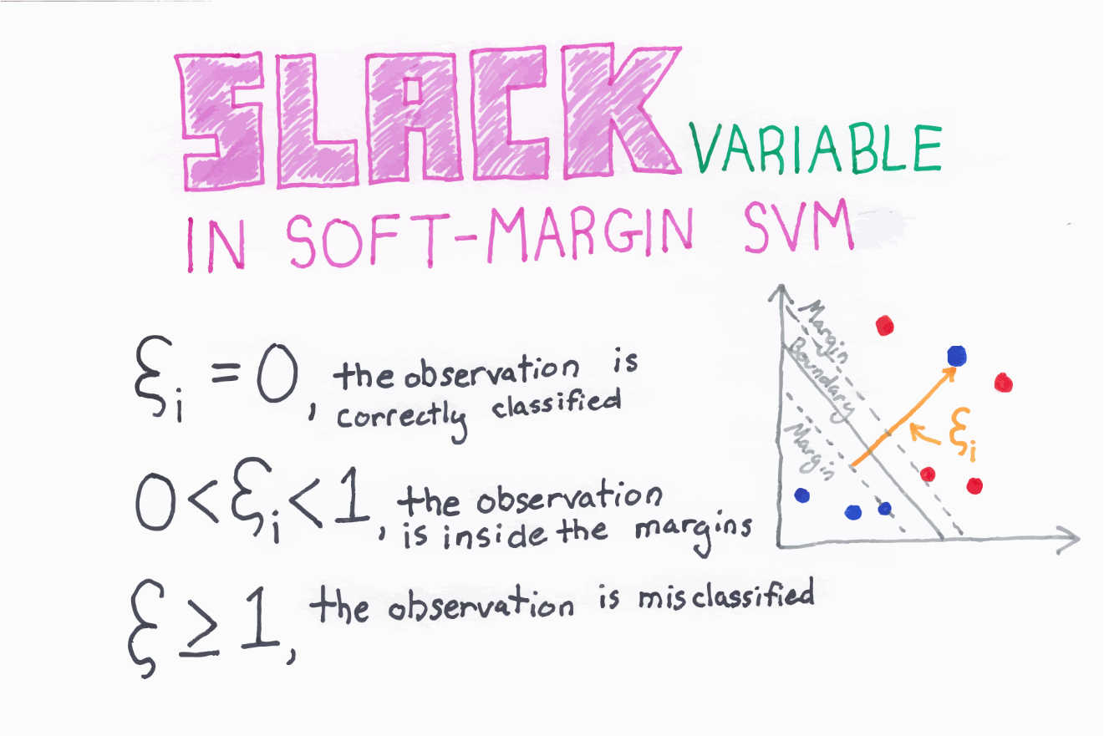

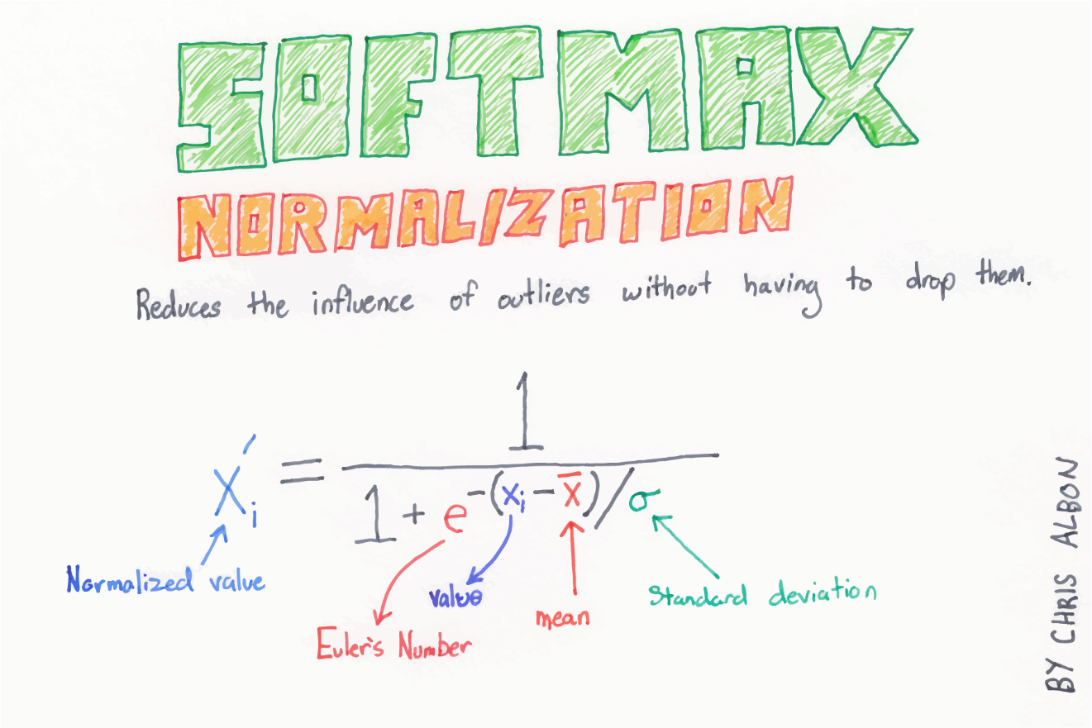

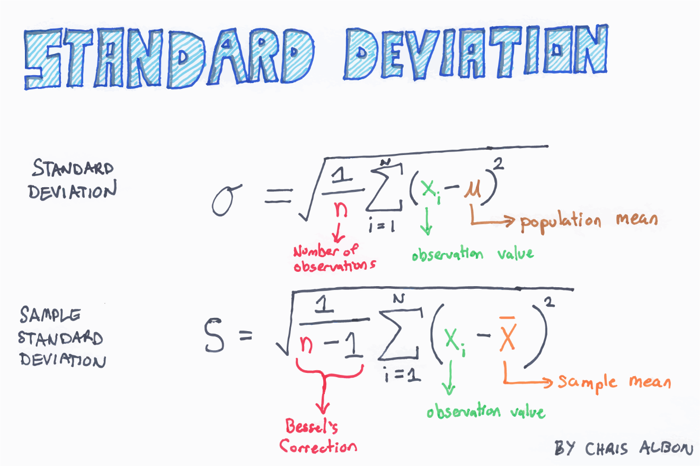

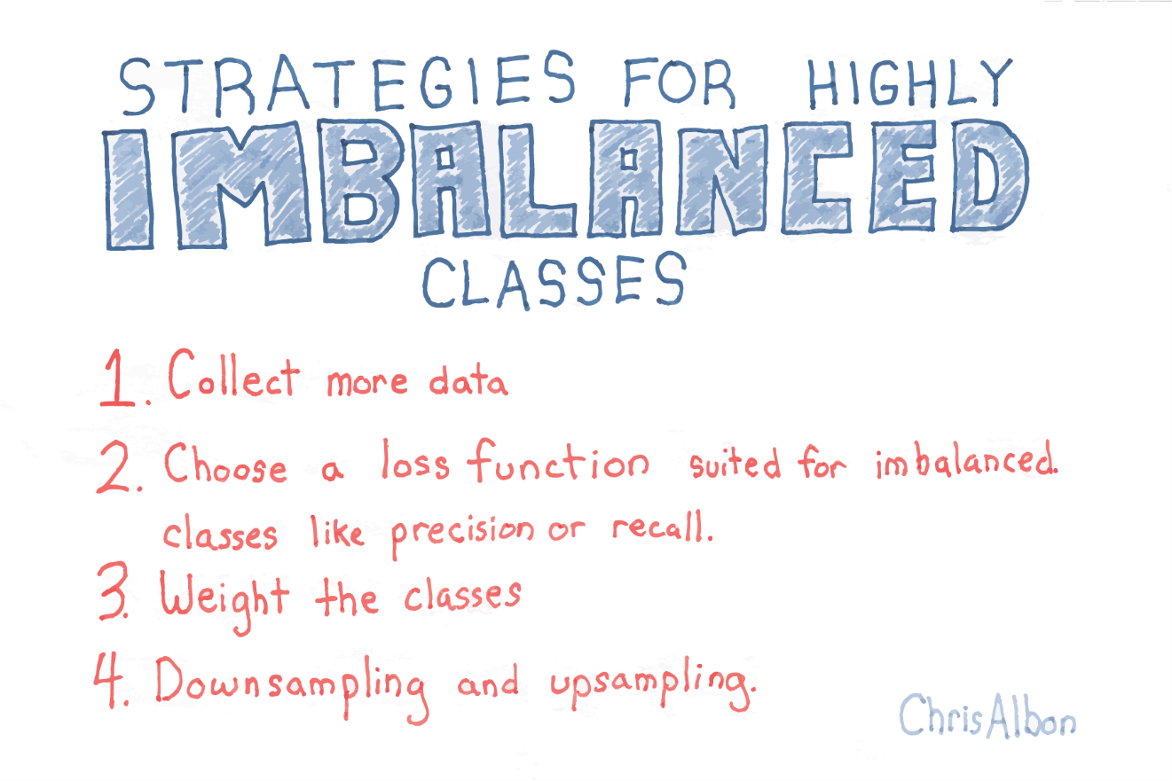

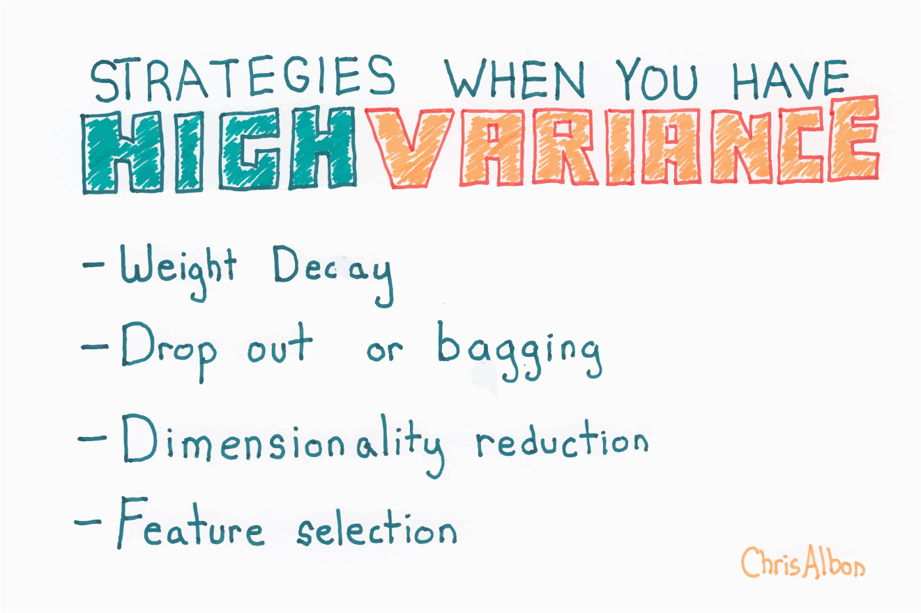

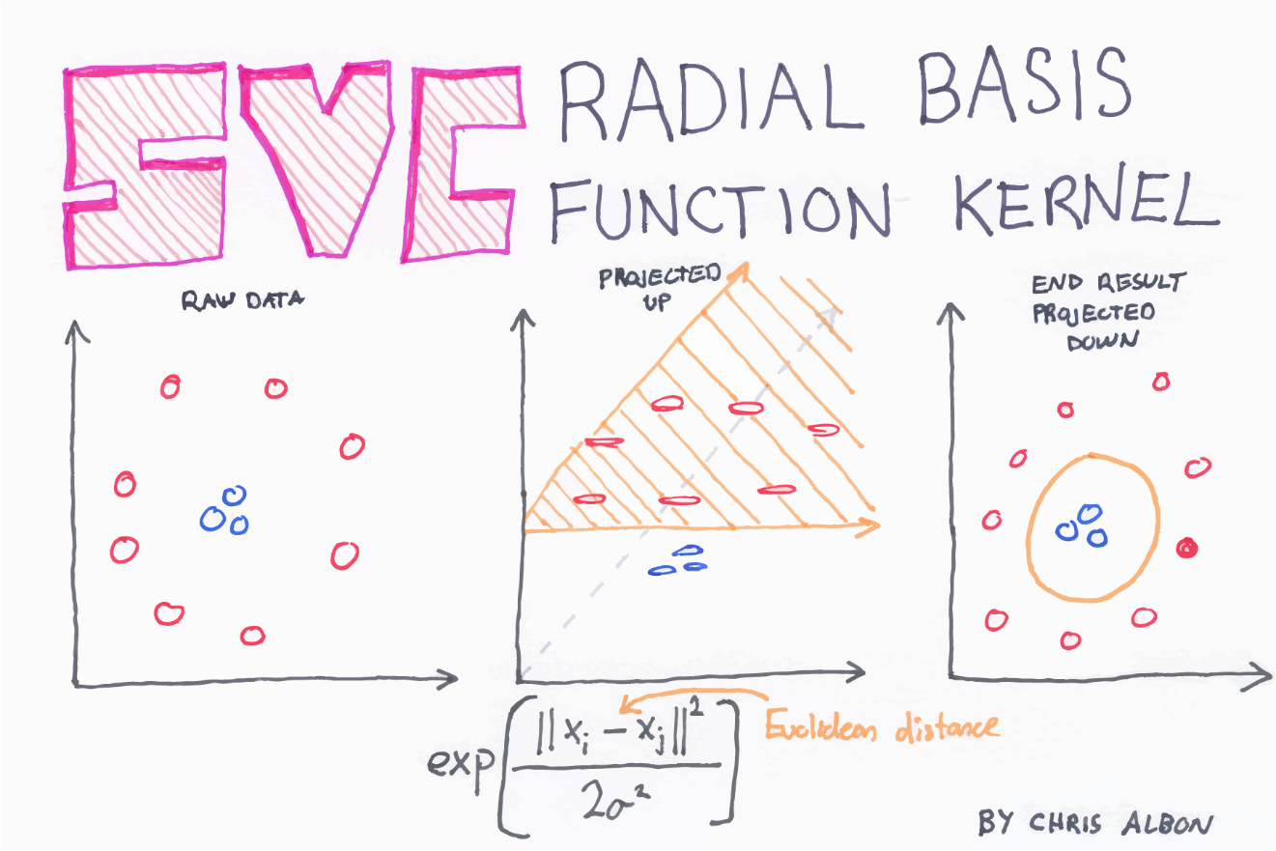

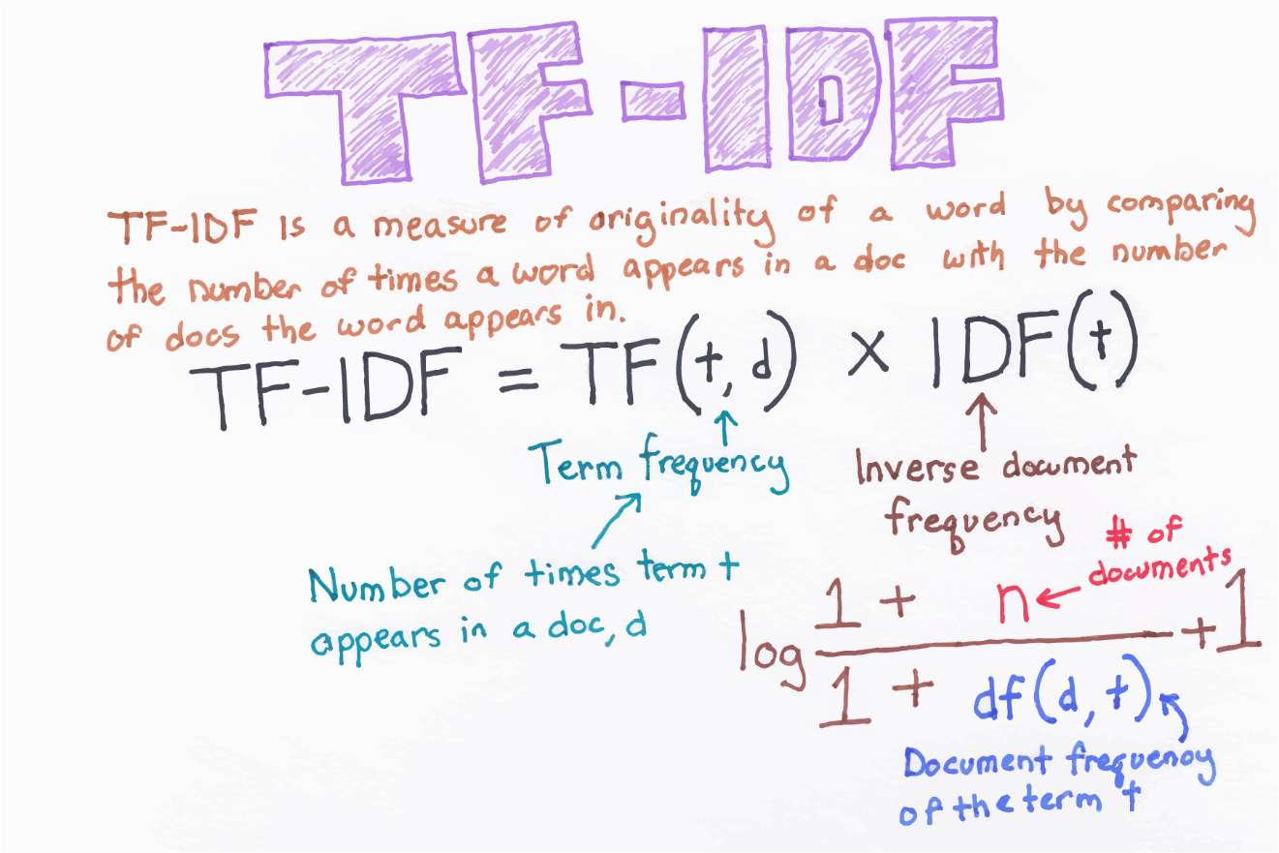

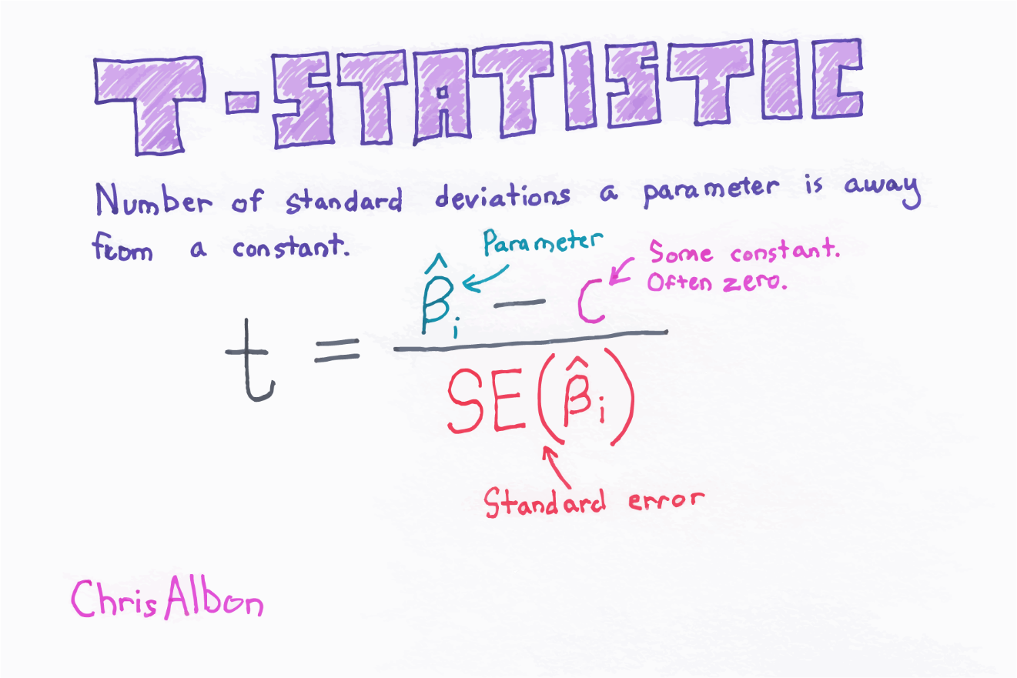

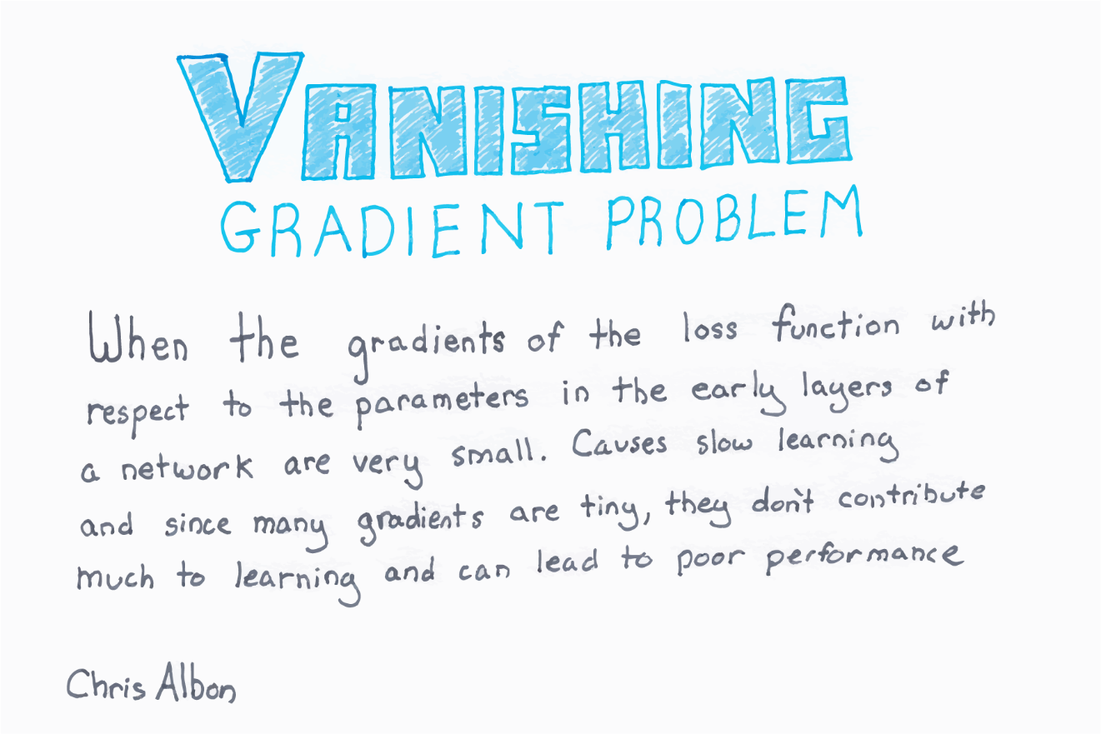

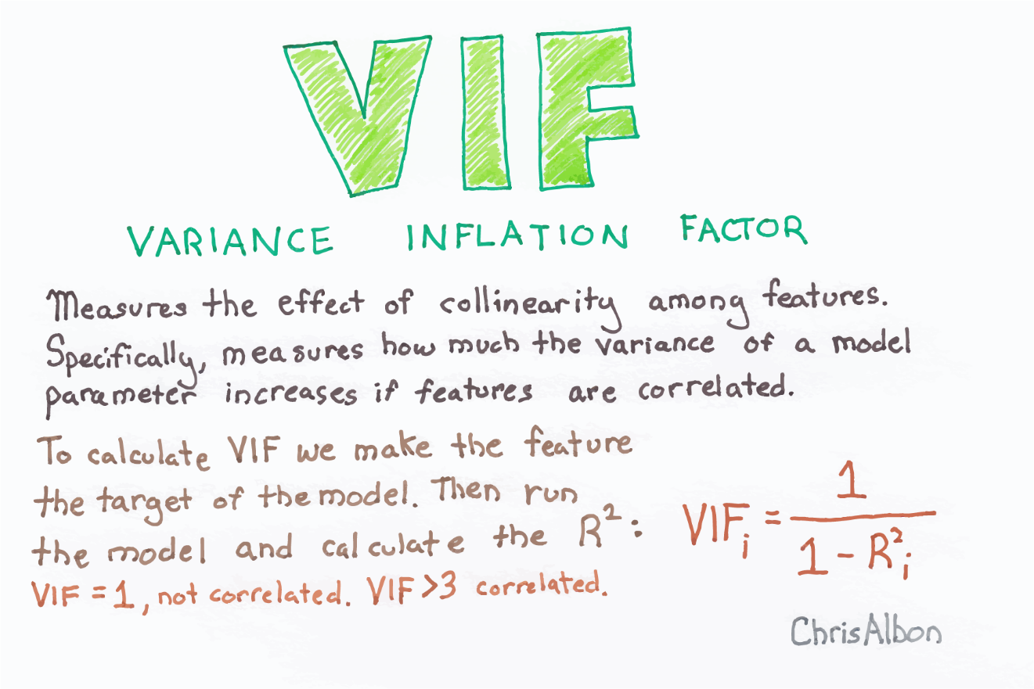

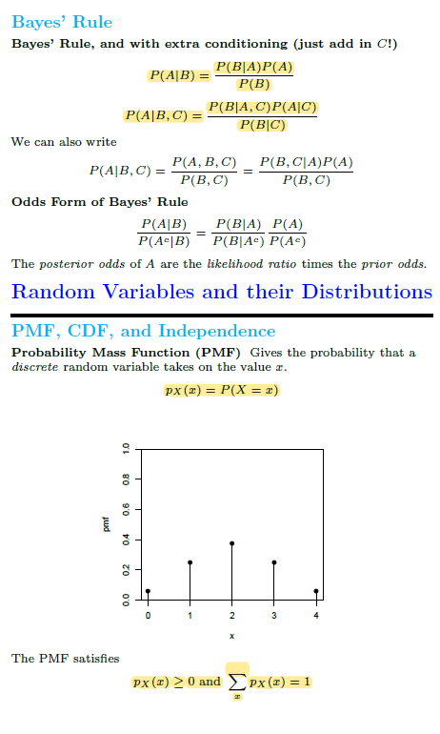

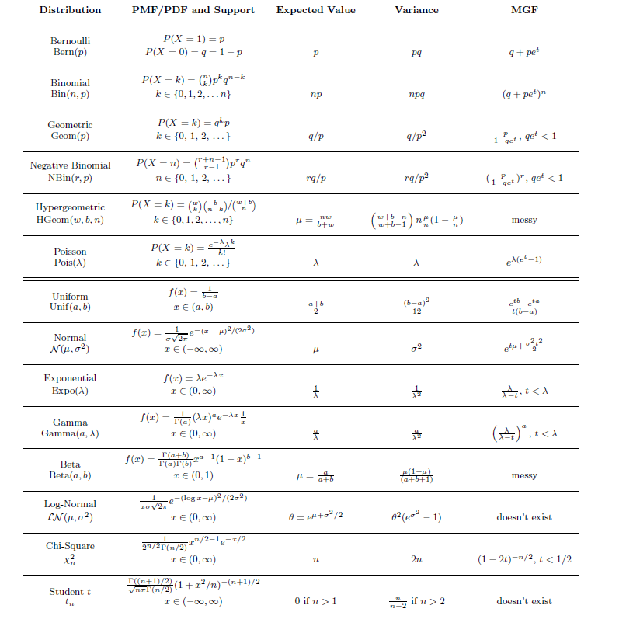

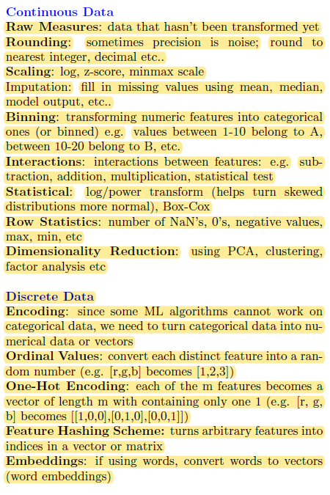 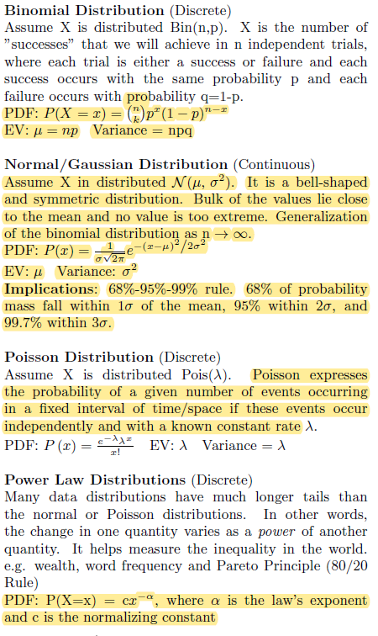 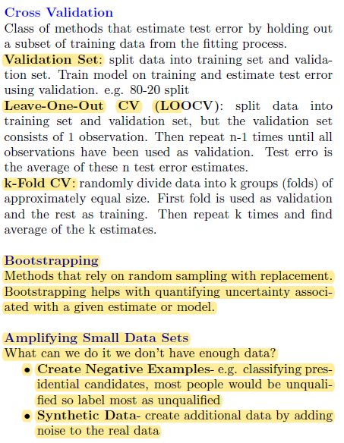 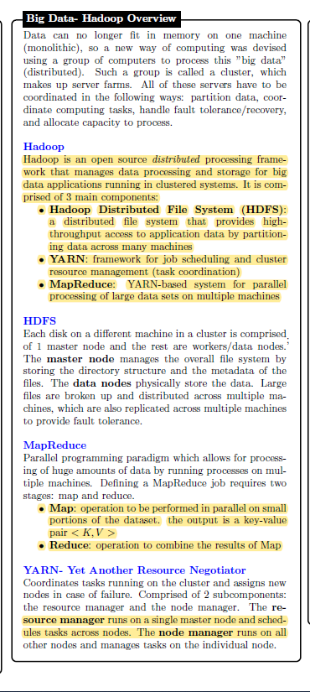 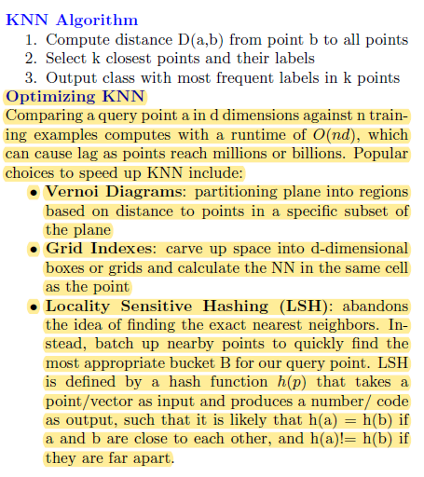

BERT (Bidirectional Encoder Representations from Transformers)

BERT (Bidirectional Encoder Representations from Transformers)[6] is a deeply bidirectional, unsupervised language

representation, pre-trained using only a plain text corpus